SIMATS ENGINEERING
Department of Information Technology
CSA15 – CLOUD COMPUTING AND BIG DATA ANALYTICS

ASSIGNMENT 2 – CO2

Analyse, Evaluate and Validate a Virtualization Architecture for a Multi-Tenant University Private Cloud
CO2: Analyze virtualization architectures to identify performance and security issues in cloud computing environments.

Field | Details | Field | Details
Student Name | K. Ragavi | Register Number | 192524364
Department / Section | Information Technology | Academic Year / Semester | 2025-2029
Faculty Name | Dr.. R. Latha | Nature of Assignment | Individual
Duration | 1 Week | Total Marks | 50
Submission Date | 04-11-2026 | Evaluation Date

CLOUD COMPUTING AND BIG DATA

ASSIGNMENT 2
CO2: Analyze virtualization architectures to identify performance and security issues in cloud computing environments.

Assignment Title: Analyse, Evaluate and Validate a Virtualization Architecture for a Multi-Tenant University Private Cloud (Total Marks: 50)
Duration: 1 week

Scenario: EduCloud Virtualization Platform
A university runs a private cloud, EduCloud, in its data centre. EduCloud currently consists of:
- 16 physical hosts, each with 64 CPU cores, 512 GB RAM, NVMe SSD storage and 2 × 25 Gbps NICs
- About 400 virtual machines (VMs) running the Student Information System (SIS), the Learning Management System (LMS), the examination portal, and departmental research workloads
- A shared storage backend and a software-defined virtual network
During semester registration week, users report slow response times and failed logins. A recent internal security audit also found that VMs from different departments share the same physical hosts, that some VMs run outdated guest kernels, and that VM images are copied freely between teams.
You are the cloud architect. You must investigate, model, measure and compare virtualization architectures for EduCloud, identify their performance bottlenecks and security weaknesses, and recommend a design that remains practical as the platform grows.

Design Challenge:
The university now plans to host external research collaborators' big-data workloads (Spark/Hadoop clusters) on the same infrastructure as the SIS. Re-evaluate your design under these new multi-tenant conditions.

TASK 1: Characterise the Virtualization Architectures (5 Marks)
Select at least three meaningfully different virtualization approaches from the following, or justify others:
- Type-1 (bare-metal) hypervisor with full virtualization
- Type-2 (hosted) hypervisor
- Hardware-assisted virtualization vs. paravirtualization
- OS-level virtualization (containers)
- Lightweight/micro-VM or sandboxed container runtimes
Two configurations of the same hypervisor will not count as different approaches. Your selection must include at least one VM-based and at least one container-based approach.
For each approach, provide:
- A layered architecture diagram showing the hardware, host OS or hypervisor, guest OS, runtime and application
- The trust boundaries and the component that enforces isolation
- How CPU, memory, storage and network are virtualized
- A brief justification for why this approach is relevant to EduCloud
Evidence expected: Three architecturally distinct approaches with labelled diagrams, resource-virtualization mechanisms, trust boundaries, and justification of selection.

TASK 2: Identify the Dominant Overhead Source (2 Marks)
For each approach, identify the primary source of performance overhead that predominantly limits its performance (for example VM exits/traps, nested or extended page-table walks, virtual I/O emulation, virtual switch processing, or system-call interception).
Discuss:
- What the overhead source is
- Where in the architecture it occurs
- Why it is appropriate as the focus of performance analysis
- How its frequency or cost changes as the number of co-located VMs/containers or the I/O rate increases
Do not simply name a mechanism. Relate it to the behaviour of the architecture.

Evidence expected: A justified dominant-overhead identification for each approach, linked to its resource-virtualization path.

TASK 3: Build a Quantitative Performance Model (6 Marks)
Using the following host parameters, develop an analytical performance model for each approach.

Parameter | Value
Physical cores per host | 64
vCPU:pCPU overcommit ratio | 1:1, 2:1, 4:1, 8:1
RAM per host | 512 GB
Average VM memory demand | 8 GB
Cost of one VM exit (assume) | 1.5 µs
Native system-call cost (assume) | 0.2 µs
Network line rate | 25 Gbps

State and justify any additional assumptions. Derive expressions for:
- CPU: effective per-VM CPU capacity as a function of overcommit ratio and virtualization overhead (including steal time)
- Memory: the maximum number of VMs per host before ballooning, swapping or page-sharing becomes necessary
- I/O and network: effective throughput as a function of the number of VMs sharing the physical device
- Density: the number of VMs/containers a host can support while meeting a stated service-level target (for example, ≤ 10% performance degradation)
Show the mathematical reasoning. Merely quoting overhead percentages from the literature will not receive full credit.
Evidence expected: A clear mathematical derivation for each approach, with stated assumptions, parameter values and worked numerical examples.

TASK 4: Analyse Performance Under Different Operating Conditions (4 Marks)
Analyse how each approach behaves under three conditions:

- Best case: what workload and placement conditions minimise overhead?
- Typical case: for example, registration-week mixed web and database load
- Worst case: for example, noisy-neighbour interference, memory overcommit with swapping, live migration during peak load, or I/O storms
For each, explain what happens inside the virtualization layer, why the overhead changes, and how latency and throughput are affected. A table of numbers alone will not be accepted.
Evidence expected: A justified condition-based analysis supported by your Task 3 model.

TASK 5: Security Threat and Vulnerability Analysis (3 Marks)
Construct a threat model for each approach. Discuss:
- The attack surface (hypervisor, device emulation, shared kernel, management plane, VM images and snapshots, virtual network)
- At least four distinct threat categories, such as VM escape, cross-VM side-channel attacks, hypervisor or container-runtime vulnerabilities, VM
sprawl and unpatched guests, image tampering, insecure live migration, and virtual-network sniffing or spoofing
- For each threat, which approach is more or less exposed and why, referring to its architecture and trust boundaries
- The likely impact on the confidentiality, integrity and availability of student records
Evidence expected: A structured threat model mapped to architectural features, with a justified comparison across approaches.

TASK 6: Formulate the Isolation–Performance Trade-off (3 Marks)
Formalise the trade-off between isolation strength and performance/density for EduCloud.
Clearly identify:
- The decision variables (for example, approach chosen, VMs per host, dedicated vs. shared hosts, SMT on/off)
- The objective(s), such as maximising density or minimising cost

- The constraints (for example, performance degradation limit, isolation requirement for SIS, available hosts)
- How these components combine into a cost or decision function
The formulation must follow from your own analysis in Tasks 3 and 5, not from a generic template.
Evidence expected: A clearly defined trade-off model with identified variables, objective and constraints.

TASK 7: Evaluate Mitigation Strategies (4 Marks)
Propose at least three mitigations for the vulnerabilities identified in Task 5. Examples include disabling SMT, kernel page-table isolation, dedicated hosts for sensitive tenants, secure or sandboxed container runtimes, hardware memory encryption, image signing, and micro-segmentation.
For each mitigation, discuss:
- Why it is applicable to the threat
- What residual risk remains
- The performance or density cost, estimated using your Task 3 model
- Whether the trade-off is acceptable for the SIS
Evidence expected: Mitigations evaluated analytically, with their security benefit and quantified performance cost.

TASK 8: Implement and Test (4 Marks)
Build a test environment and experimentally test all selected approaches.
- Platforms: use any open-source stack, for example KVM/QEMU, Xen or VirtualBox, Docker/Podman, and Kata Containers or gVisor. Nested virtualization on a laptop is acceptable if documented.
- Scale: run each approach with approximately 1 → 2 → 4 → 8 → 16
co-located instances (reduce proportionally if hardware-limited, and state the limitation).
- Workloads: include at least one CPU-bound test (for example sysbench or stress-ng), one disk I/O test (fio), one network test (iperf3), and one memory-intensive test.
- Interference test: run at least one noisy-neighbour experiment.

- Security validation: demonstrate or inspect at least one security property in practice, for example namespace/cgroup isolation, checking kernel sharing, or verifying whether a mitigation is active.
Ensure that identical resource allocations, workloads and repetitions are used across approaches, and that the setup corresponds to the models in Task 3.
Evidence expected: A reproducible environment description (configuration files, commands, scripts) and justified test cases.

TASK 9: Record Experimental Performance (3 Marks)
Collect and present data such as:
- Throughput, latency (mean and 95th percentile), CPU steal time, context switches and VM exits where observable
- Instance start-up time and memory footprint per instance
- Performance degradation versus a bare-metal baseline
- Results with and without at least one security mitigation
Present at least one table and two graphs (for example, throughput versus number of instances, and latency under interference). Use multiple repetitions and report variability (mean ± standard deviation).
Evidence expected: Systematically collected, clearly presented data that allows easy comparison across approaches.

TASK 10: Compare Theory with Experiment (4 Marks)
Compare your Task 3 and Task 4 predictions with Task 9 measurements. Discuss:
- Whether the observed degradation trends agree with your model
- Which approach scales better as co-located instances increase
- Quantitative differences between predicted and measured values, and plausible causes (for example caching effects, hypervisor scheduler behaviour, nested virtualization, laptop hardware, or unmodelled I/O paths)
- Whether any measured result changes your security conclusions from Task 5
Interpret the results; do not simply reproduce tables.
Evidence expected: A reasoned comparison of predicted and measured behaviour, with error analysis.

TASK 11: Recommend and Defend the Final Architecture (4 Marks)
Recommend the virtualization architecture (or hybrid) for EduCloud's SIS and LMS workloads.
Discuss:
- Which approach you recommend and why it is more appropriate than the alternatives
- Its modelled and experimentally observed performance
- Its security posture and residual risks
- Operational costs such as patching, image management, migration and monitoring
- Limitations and trade-offs
- Whether it remains practical as EduCloud grows from 400 to several thousand instances
Your recommendation must rest on your own analysis and experiments. Choosing "the most secure" or "the fastest" option alone is not sufficient.
Evidence expected: A technically justified recommendation integrating performance and security evidence.

DAY-4 DESIGN CHALLENGE

TASK 12: Re-evaluate and Adapt the Design (8 Marks)

Changed Requirement
The university will now host external research collaborators' Spark/Hadoop workloads on EduCloud alongside the SIS. The new conditions are:
- Big-data jobs are I/O- and network-intensive and run for hours
- Registration-week peak load is about 3× normal
- Hosts are sometimes patched using live migration of running VMs
- A data-protection regulation now requires demonstrable isolation of student records from external tenants
You may RETAIN → MODIFY → or REDESIGN your original solution.

TASK 1: Characterise the Virtualization Architectures (5 Marks)
EduCloud must host a transaction-critical student information system (SIS), a learning management system (LMS), an examination portal, internal research workloads and, in future, external Spark/Hadoop tenants. Four meaningfully different approaches are selected. They differ in what enforces isolation (hardware, a shared kernel, a user-space kernel, or hardware plus a minimal guest kernel), not merely in configuration:
- A. Type-1 hypervisor, full virtualization with hardware assistance (KVM/QEMU with VT-x, EPT, virtio): VM-based.
- B. OS-level virtualization (Docker/runc: namespaces and cgroups): container-based.
- C. Sandboxed container runtime (gVisor/runsc: user-space kernel that intercepts system calls): container-based.
- D. Lightweight micro-VM (Kata Containers: one micro-VM per pod with a minimal guest kernel): VM-based.
A Type-2 (hosted) hypervisor such as VirtualBox is not selected: it runs on top of a general-purpose host OS, adds an extra layer (guest → VMM → host OS → hardware) and a larger trusted computing base, so it is unsuitable for a production data centre. It is useful only for the laptop-based tests of Task 8. Hardware-assisted virtualization (approach A) is used instead of paravirtualization because modern CPUs make unmodified guests fast; paravirtual drivers (virtio) are still used for I/O.

Approach A: Type-1 hardware-assisted VM (KVM)
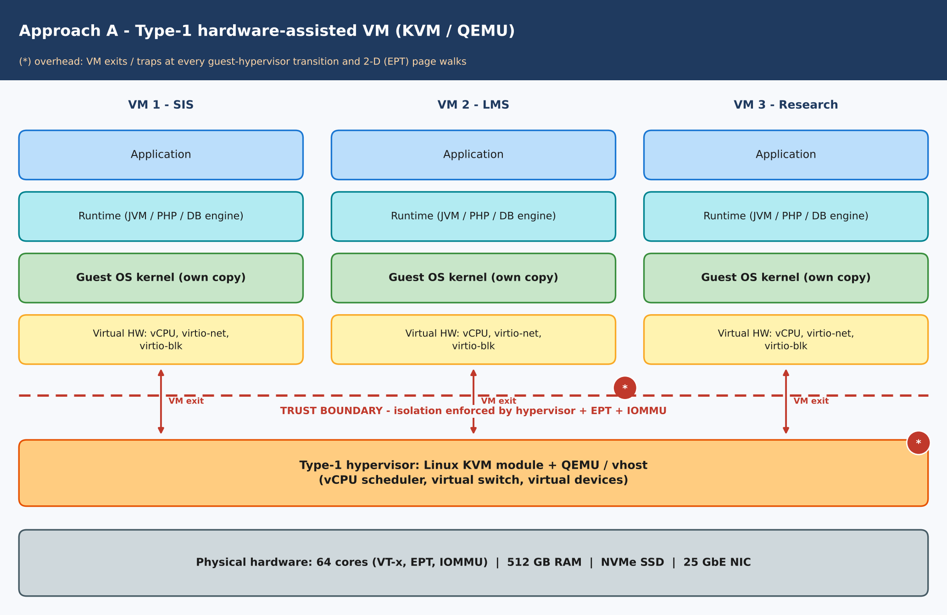
Figure 1.1: Layered architecture of approach A – Type-1 hardware-assisted VM (KVM)
Aspect | Description
Trust boundary / isolation enforcer | Boundary between each guest and the hypervisor. Enforced by the hypervisor (KVM), hardware EPT page tables and the IOMMU. Each VM has its own guest kernel, so a guest compromise does not directly expose the host kernel.
CPU | vCPUs are host threads. VT-x/AMD-V runs guest code natively; privileged operations cause a VM exit to KVM. The host scheduler time-slices vCPUs over pCPUs (overcommit).
Memory | Guest-physical to host-physical mapping through Extended Page Tables (2-D page walk). Ballooning, KSM page sharing and swap are available.
Storage | virtio-blk/virtio-scsi on NVMe-backed qcow2/raw images; I/O is handled by QEMU or vhost I/O threads.
Network | virtio-net with vhost-net, connected to a Linux bridge or Open vSwitch (the software-defined network).
Relevance to EduCloud | Strong isolation between departments with differing patch levels; guests may run outdated kernels without exposing the host kernel. It is the closest match to the current EduCloud and the likely base for SIS.

Approach B: OS-level virtualization (Docker)
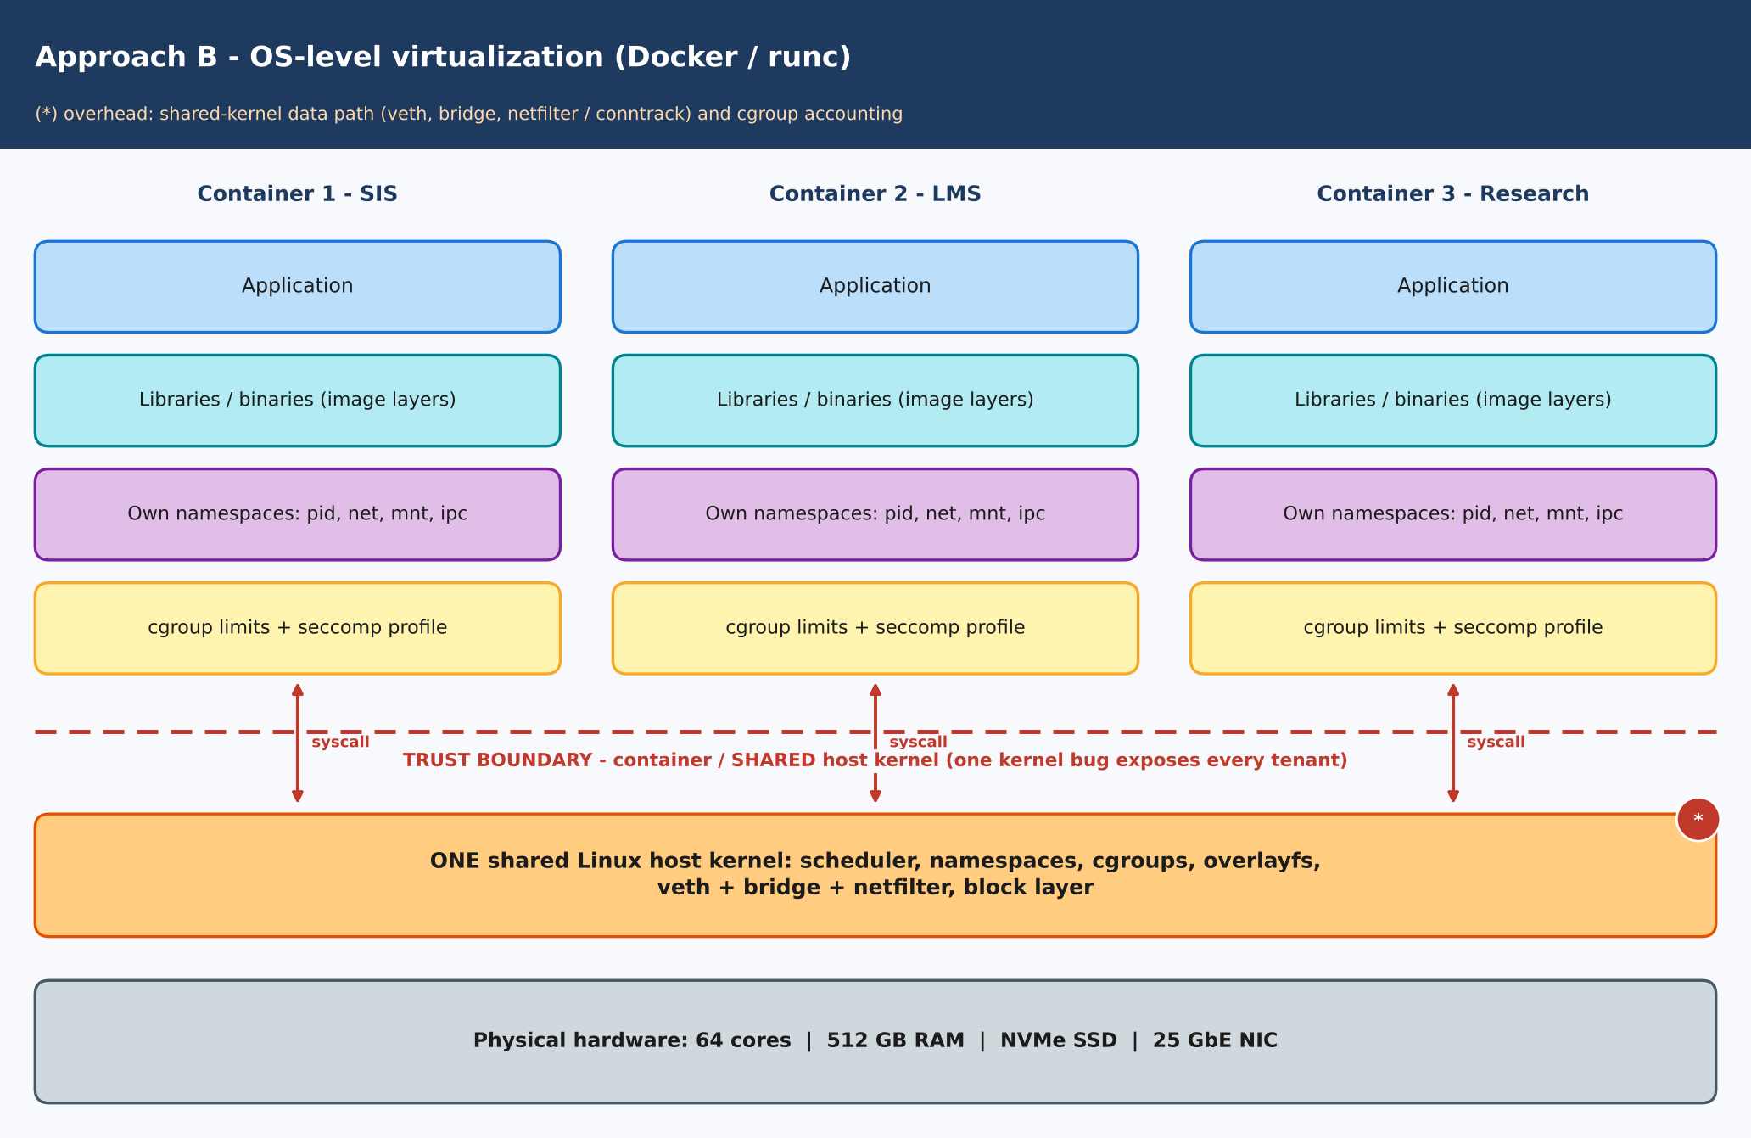
Figure 1.2: Layered architecture of approach B – OS-level virtualization (Docker / runc)
Aspect | Description
Trust boundary / isolation enforcer | Boundary between container and the SHARED host kernel. Enforced by kernel namespaces, cgroups, seccomp and SELinux/AppArmor. All containers use the same kernel, so one kernel vulnerability affects every tenant.
CPU | Processes scheduled directly by the host scheduler; cgroup CPU shares/quotas limit use. No instruction trapping.
Memory | Ordinary host virtual memory, limited by cgroup memory controller; the page cache is shared and counted per cgroup.
Storage | overlayfs layers on the host filesystem or bind-mounted volumes; I/O goes straight to the host block layer.
Network | Each container has a network namespace with a veth pair attached to a Linux bridge, with iptables/netfilter NAT and filtering.
Relevance to EduCloud | Highest density, fast start-up (seconds) and easy image distribution for stateless web tiers and trusted internal research. The weak isolation is a concern for SIS and external tenants.

Approach C: Sandboxed container (gVisor)
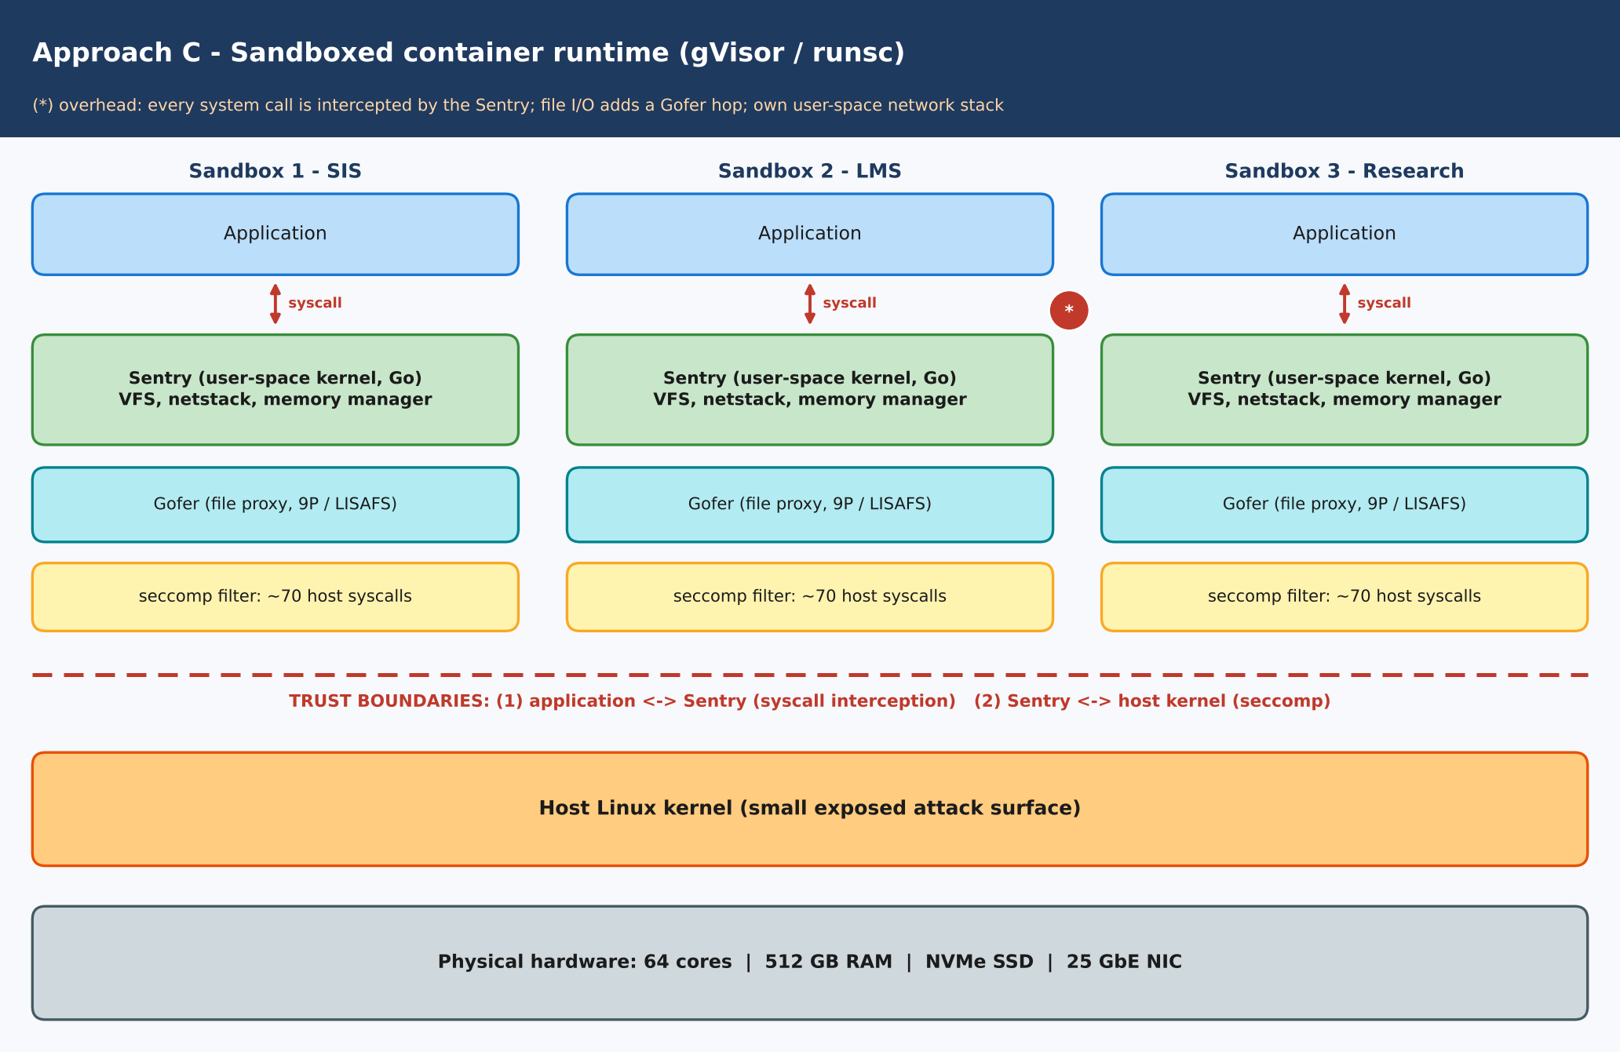
Figure 1.3: Layered architecture of approach C – Sandboxed container runtime (gVisor)
Aspect | Description
Trust boundaries / isolation enforcer | Two boundaries. (1) Application ↔ Sentry: every system call is intercepted by gVisor's user-space kernel (the Sentry). (2) Sentry ↔ host kernel: a seccomp filter exposes only about 70 host system calls. The Sentry (written in Go) is the enforcer.
CPU | Application threads are scheduled by the host but system calls and page faults are trapped (ptrace, systrap or KVM platform) and served by the Sentry.
Memory | The Sentry implements guest memory management and maps memory from the host; page faults are handled in user space.
Storage | A separate Gofer process mediates file access (9P/LISAFS), so each file operation crosses two processes.
Network | Own user-space TCP/IP stack (netstack) in the Sentry; packets leave through an AF_PACKET or host-network path.
Relevance to EduCloud | Gives container-like start-up and image workflow but a much smaller host-kernel attack surface. Suitable for untrusted code (for example external users' jobs) when syscall rates are modest.

Approach D: Micro-VM (Kata Containers)
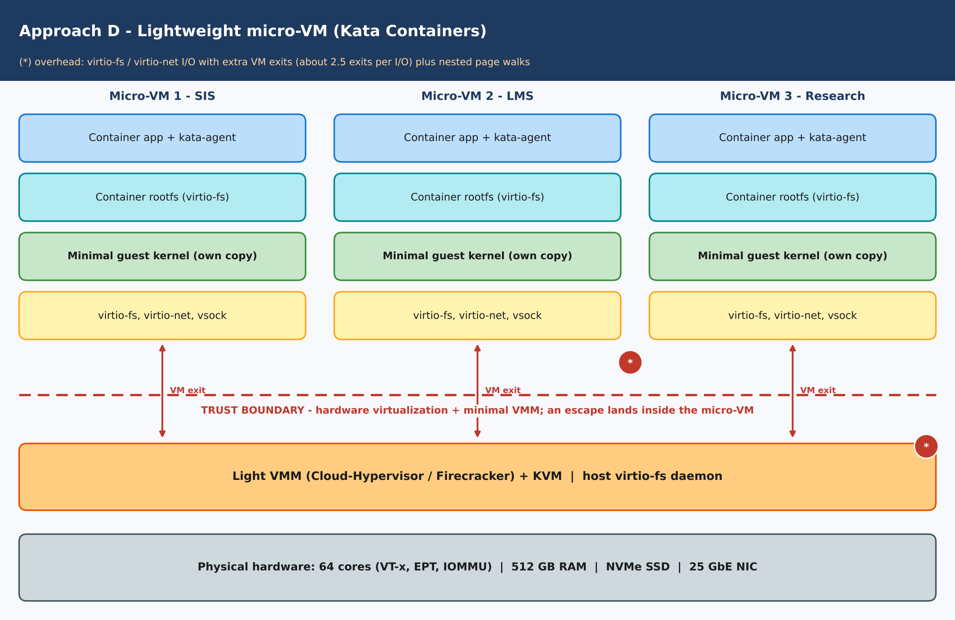
Figure 1.4: Layered architecture of approach D – Lightweight micro-VM (Kata Containers)
Aspect | Description
Trust boundary / isolation enforcer | Boundary between each micro-VM and the host. Enforced by hardware virtualization (EPT, IOMMU) and a minimal VMM. Each pod has its own small guest kernel, so a container escape lands inside the micro-VM, not the host.
CPU | Guest runs natively under VT-x; exits to the lightweight VMM (Cloud-Hypervisor/Firecracker/QEMU-lite) for privileged operations; vCPUs may be hot-plugged.
Memory | EPT-based; minimal guest (about 100–200 MB) with DAX/virtio-mem options to reduce footprint.
Storage | virtio-fs (FUSE-based) shares the container rootfs from the host, or virtio-blk block devices.
Network | virtio-net (vhost) through a tap device and bridge/CNI; vsock for host–agent control.
Relevance to EduCloud | VM-grade isolation with container-style orchestration. It is attractive for external big-data tenants and for departmental workloads that must share hosts.

TASK 2: Identify the Dominant Overhead Source (2 Marks)
The overhead that limits each approach is the one whose cost is paid on the hot path of the workload, that is, a mechanism that runs repeatedly (per I/O, per system call, per memory miss). The overhead locations are marked (*) in Figures 1.1–1.4.

A. KVM full VM
- VM exits / traps. When the guest executes a privileged operation (I/O kick, interrupt injection, HLT, IPI, MSR access) the CPU leaves guest mode and enters KVM. Each exit costs about t_{exit} = 1.5 µs (state save, handling, re-entry, cache/TLB disturbance).
- Where: at every guest ↔ hypervisor transition (Figure 1.1, between guest virtual hardware and KVM).
- Why the focus: guest user code runs at native speed, so exits are the main thing separating a VM from bare metal. The exit rate is directly observable (perf kvm stat).
- Scaling: exit rate per host = n·v·[f₀(1 + α(r − 1)) + e_{io}λ]. It grows linearly with the number of VMs n and with I/O rate λ, and superlinearly with overcommit because more runnable vCPUs mean more HLT/IPI exits and lock-holder preemption.

B. Docker container
- Virtual-network and cgroup processing in the shared kernel. Packets traverse veth, bridge and netfilter/conntrack for every container; cgroup accounting is charged on every scheduling and memory event.
- Where: inside the host kernel network stack and cgroup controllers (Figure 1.2). There are no VM exits and no system-call interception.
- Why the focus: CPU and memory run natively, so the shared kernel data-path is the only added cost. It also couples tenants, because they compete for the same locks and conntrack table.
- Scaling: cost per packet (c_{dp} = 1.5 µs) is constant, but total time λ·c_{dp} grows with the I/O rate; contention for kernel locks and conntrack entries grows with the number of containers n (modelled by γ·log₂n).

C. gVisor sandbox
- System-call interception. Every application system call is redirected into the Sentry. Native cost is 0.2 µs; interception costs about 2.0 µs (a 10× increase), plus a Gofer hop for file I/O and a user-space network stack.
- Where: at the application ↔ Sentry boundary (Figure 1.3), on every syscall.
- Why the focus: web servers and databases make tens of thousands of syscalls per second, so interception cost dominates everything else.
- Scaling: overhead = λ_{s}(t_{g} − t_{sys}), linear in the syscall rate and independent of n, but the Sentry's own CPU use scales with n (one Sentry per sandbox), reducing the CPU left for applications.

D. Kata micro-VM
- Virtual I/O emulation (virtio-fs and virtio-net) with its VM exits. File access goes guest → virtio-fs/FUSE → host daemon, and every request kick causes an exit. Nested page-table walks add a smaller share.
- Where: at the virtio device layer between guest kernel and VMM (Figure 1.4).
- Why the focus: container-style workloads are file- and network-intensive; the exits per I/O (e_{io} ≈ 2.5) are higher than for plain KVM.
- Scaling: exit rate = n·v·[f₀(1 + α(r − 1)) + 2.5λ]. It rises linearly with n and the I/O rate, and faster than KVM because e_{io} is larger.
The Task 3 model uses exactly these terms. For the typical mixed load at 2:1 overcommit, the overhead they produce is: KVM 4.5 %, Docker 1.6 %, gVisor 12.0 %, Kata 5.8 %.

TASK 3: Build a Quantitative Performance Model (6 Marks)

3.1 Notation and assumptions
Given host parameters: P = 64 cores, M = 512 GB, overcommit r ∈ {1, 2, 4, 8}, average VM memory m = 8 GB, VM-exit cost t_{exit} = 1.5 µs, native syscall cost t_{sys} = 0.2 µs, line rate B = 25 Gbps. Additional assumptions (stated and justified):
- Every instance has v = 4 vCPUs and m = 8 GB, which is consistent with the 8 GB average memory demand. The current load of about 400 VMs on 16 hosts gives 25 VMs per host.
- u is the average utilisation of a vCPU: u = 0.6 for a typical day and u = 0.9 for registration week (peak).
- M_{h} = 16 GB is reserved for the host OS, hypervisor and page tables.
- VM-exit rate per vCPU: f(r) = f₀[1 + α(r − 1)] with f₀ = 3,000 /s (timer, IPI, HLT) and α = 0.15, because more runnable vCPUs per pCPU increase HLT/IPI exits and lock-holder preemption.
- I/O rate λ = 4,000 I/O operations/s per vCPU (typical). Exits per I/O: e_{io} = 1 for KVM (virtio with vhost batching) and 2.5 for Kata (virtio-fs adds a FUSE hop); 0 for containers.
- Host data-path CPU cost per I/O, c_{dp}: KVM 1.0 µs (vhost), Docker 1.5 µs (veth/bridge/netfilter), gVisor 5.0 µs (user-space netstack + Gofer), Kata 2.0 µs.
- Nested paging: a fraction φ = 5 % of native run time is spent in TLB-miss page walks, and a 2-D (EPT) walk costs κ = 1.6× a native walk, so the penalty is φ(κ − 1) = 3 % (VM-based approaches only).
- gVisor intercepts each syscall at t_{g} = 2.0 µs (10× native) with λ_{s} = 50,000 syscalls/s per vCPU for a web/database mix. Containers add o_{cg} = 1 % for cgroup/seccomp accounting.
- Per-instance memory overhead: m_{o} = m(1 + ε) + c, with (ε, c) = KVM (0.03, 0.40 GB), Docker (0, 0.02 GB), gVisor (0.01, 0.15 GB), Kata (0.02, 0.20 GB). KSM (page sharing) can save σ = 15 % for identical guest images.
- Network: one instance reaches η_{a}B of the line rate, with η = 0.94 (bare metal), 0.90 (KVM), 0.92 (Docker), 0.45 (gVisor), 0.85 (Kata). Virtual-switch contention reduces throughput by γ·log₂n, with γ = 0.010 / 0.015 / 0.060 / 0.020 for KVM / Docker / gVisor / Kata.
- Disk: NVMe delivers 600 k IOPS (4 KiB random); efficiency η_{io} = 1.00 (bare), 0.80 (KVM), 0.95 (Docker), 0.30 (gVisor), 0.55 (Kata).

3.2 CPU model: effective per-vCPU capacity
The virtualization overhead of approach a at overcommit r is the sum of its overhead terms (a term applies only to the approaches that have it):
o_{a}(r) = o_{cg} + [ f₀(1 + α(r − 1)) + e_{io}·λ ]·t_{exit} + φ(κ − 1) + λ·c_{dp} + λ_{s}(t_{g} − t_{sys}) (1)
If vCPU demand u, multiplied by the overcommit ratio r, exceeds one, vCPUs wait for a pCPU. That waiting time is the steal time:
s(r,u) = 1 − min{ 1, 1/(r·u) } (2)
Effective capacity of one vCPU, as a fraction of one physical core, is then:
C_{vCPU}(r,u) = (1 − o_{a}(r)) · (1 − s(r,u)) = (1 − o_{a}(r)) · min{ 1, 1/(r·u) } (3)
Worked example (KVM, r = 2, typical load). f(2) = 3000(1 + 0.15) = 3,450 /s. Exits: (3,450 + 1×4,000) = 7,450 /s × 1.5 µs = 1.12 %. vhost data path: 4,000 × 1.0 µs = 0.40 %. Nested paging: 3.00 %. Hence o = 4.52 %. With u = 0.6, r·u = 1.2 > 1, so s = 1 − 1/1.2 = 16.7 % and C = 0.9548 × 0.8333 = 0.796 pCPU per vCPU. The same calculation gives Docker 1.60 % (0.01 + 4,000 × 1.5 µs), gVisor 12.0 % (0.01 + 2 % + 50,000 × 1.8 µs = 9 %) and Kata 5.82 %.
Table 3.1(a): Effective capacity per vCPU, C_vCPU(r,u), typical load u = 0.6
Approach | r = 1:1 | r = 2:1 | r = 4:1 | r = 8:1
Type-1 KVM VM | 0.956 | 0.796 | 0.397 | 0.198
Docker (runc) | 0.984 | 0.820 | 0.410 | 0.205
gVisor (runsc) | 0.880 | 0.733 | 0.367 | 0.183
Kata micro-VM | 0.943 | 0.785 | 0.392 | 0.195
Steal time s(r, 0.6) | 0.0 % | 16.7 % | 58.3 % | 79.2 %
Table 3.1(b): Effective capacity per vCPU, fully loaded u = 1.0 (worst case)
Approach | r = 1:1 | r = 2:1 | r = 4:1 | r = 8:1
Type-1 KVM VM | 0.956 | 0.477 | 0.238 | 0.119
Docker (runc) | 0.984 | 0.492 | 0.246 | 0.123
gVisor (runsc) | 0.880 | 0.440 | 0.220 | 0.110
Kata micro-VM | 0.943 | 0.471 | 0.235 | 0.117
Steal time s(r, 1.0) | 0.0 % | 50.0 % | 75.0 % | 87.5 %
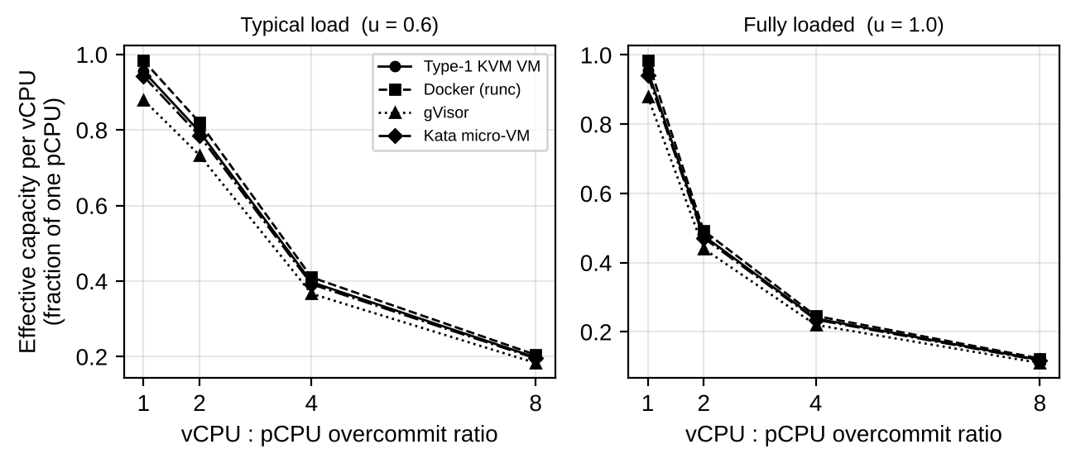
Figure 3.1: Effective capacity per vCPU versus overcommit ratio
Interpretation. Steal time, not virtualization overhead, dominates beyond 2:1: at u = 0.6 a vCPU keeps full capacity only while r·u ≤ 1 (r ≤ 1.67), and at u = 1.0 capacity falls as 1/r. The approaches differ by a few percent in the ordering Docker < KVM < Kata < gVisor, but all lose about 50 % of their capacity at 2:1 under full load. Overcommit therefore has to be limited for latency-sensitive services, whatever the approach.

3.3 Memory model: maximum VMs per host
m_{o} = m(1 + ε) + c ; N_{mem} = ⌊ (M − M_{h}) / m_{o} ⌋ ; N_{mem,KSM} = ⌊ (M − M_{h}) / (m_{o}(1 − σ)) ⌋ (4)
N_{mem} is the number of instances that fit before ballooning, swapping or page sharing becomes necessary. The vCPU-bound count is N_{cpu} = ⌊P·r/v⌋; a host is limited by the smaller of the two. Example (KVM): m_{o} = 8(1.03) + 0.40 = 8.64 GB, so N_{mem} = ⌊496 / 8.64⌋ = 57.
Table 3.2: Memory-limited density per host (RAM 512 GB, reserve 16 GB)
Approach | m_{o} (GB) | N_{mem} | N_{mem} with KSM (σ = 15 %) | Equivalent overcommit N_{mem}·v/P
Type-1 KVM VM | 8.64 | 57 | 67 | 3.56 : 1
Docker (runc) | 8.02 | 61 | 72 | 3.81 : 1
gVisor (runsc) | 8.23 | 60 | 70 | 3.75 : 1
Kata micro-VM | 8.36 | 59 | 69 | 3.69 : 1
Interpretation. About 57–61 instances of 8 GB fit in 496 GB. At 4:1 overcommit, 64 four-vCPU VMs would need 512 GB, so memory becomes the binding limit near 3.6:1. The present 25 VMs per host use only about 200 GB (40 % of RAM), so memory is not the cause of the registration-week slowdown; CPU contention is (Section 3.6). Beyond 57 VMs, ballooning or KSM (67 VMs for KVM) is needed.

3.4 I/O and network model
T_{i}(n) = η_{a}·B·(1 − γ_{a}·log₂n) / n ; IOPS_{i}(n) = η_{io,a}·IOPS_{dev} / n (5)
T_{i}(n) is the throughput of one of n instances that share the 25 Gbps NIC fairly, and the aggregate is n·T_{i}(n). Example (KVM, n = 8): 0.90 × 25 × (1 − 0.010 × 3) / 8 = 2.73 Gbps.
Table 3.3: Network throughput per instance (Gbps) versus number of instances sharing one 25 GbE NIC
Approach | n = 1 | n = 2 | n = 4 | n = 8 | n = 16
Bare metal | 23.50 | 11.75 | 5.88 | 2.94 | 1.47
Type-1 KVM VM | 22.50 | 11.14 | 5.51 | 2.73 | 1.35
Docker (runc) | 23.00 | 11.33 | 5.58 | 2.75 | 1.35
gVisor (runsc) | 11.25 | 5.29 | 2.48 | 1.15 | 0.53
Kata micro-VM | 21.25 | 10.41 | 5.10 | 2.50 | 1.22
Table 3.4: Random-read IOPS per instance (thousands) versus number of instances sharing the NVMe device
Approach | n = 1 | n = 2 | n = 4 | n = 8 | n = 16
Bare metal | 600.0 | 300.0 | 150.0 | 75.0 | 37.5
Type-1 KVM VM | 480.0 | 240.0 | 120.0 | 60.0 | 30.0
Docker (runc) | 570.0 | 285.0 | 142.5 | 71.2 | 35.6
gVisor (runsc) | 180.0 | 90.0 | 45.0 | 22.5 | 11.2
Kata micro-VM | 330.0 | 165.0 | 82.5 | 41.2 | 20.6
Interpretation. Per-instance throughput falls as 1/n because the physical device is the shared resource. Docker and KVM stay within about 2–8 % of bare-metal network throughput, whereas gVisor's user-space stack achieves less than half the line rate even for a single instance. For disk, virtio-fs (Kata) and the Gofer (gVisor) cut IOPS to 55 % and 30 % respectively, which matters for the SIS database.

3.5 Density model under a service-level target
The target is at most D_{max} = 10 % performance degradation, that is C_{vCPU}(r,u) ≥ 0.90. Substituting equation (3):
r_{max}(u) = (1 − o_{a}) / ((1 − D_{max})·u) if o_{a} ≤ D_{max} (otherwise the target cannot be met) ; N_{SLA} = min{ ⌊P·r_{max}/v⌋ , N_{mem} } (6)
Derivation: when r·u ≤ 1 there is no steal and only o_{a} ≤ D_{max} is needed; when r·u > 1 we need (1 − o_{a})/(r·u) ≥ 1 − D_{max}, which gives r ≤ (1 − o_{a})/((1 − D_{max})u).
Table 3.5: Largest overcommit ratio r_{max} and instances per host N_{SLA} meeting the 10 % target
Approach | o_{a}(r=1) | r_{max}(u = 0.6) | N_{SLA}(u = 0.6) | N_{SLA}(u = 0.9) | Comment
Type-1 KVM VM | 4.5 % | 1.77 | 28 | 18 | Meets target
Docker (runc) | 1.6 % | 1.82 | 29 | 19 | Highest density
gVisor (runsc) | 12.0 % | – | 0 | 0 | o_{a} > 10 %: target not met
Kata micro-VM | 5.8 % | 1.75 | 27 | 18 | Meets target
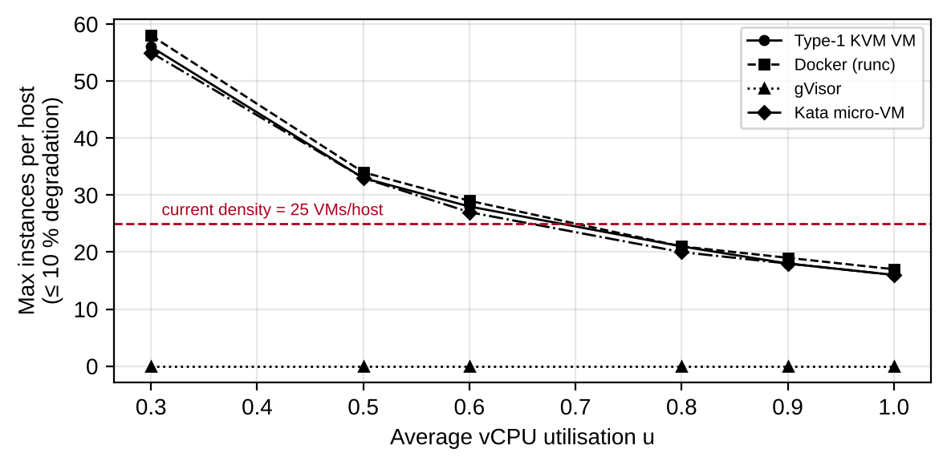
Figure 3.2: Maximum instances per host within 10 % degradation versus utilisation

3.6 What the model says about the current EduCloud
EduCloud runs 25 VMs × 4 vCPU = 100 vCPUs on 64 cores, so r = 1.56:1. At u = 0.6, r·u = 0.94 and there is no steal, so the system behaves well on normal days. In registration week u rises to 0.9, so r·u = 1.40 and steal is 1 − 1/1.40 = 28.9 %: each vCPU loses almost a third of its time waiting for a core. The 10 % target allows only 18 VMs per host at u = 0.9 (Table 3.5), against the 25 now deployed. This explains the slow responses and failed logins, as the login timeouts occur when the queue of runnable vCPUs grows.

TASK 4: Analyse Performance Under Different Operating Conditions (4 Marks)
Three conditions are defined by workload parameters in the Task 3 model (all at r = 2:1): Best (u = 0.3, f₀ = 1,000, λ = 200, λ_{s} = 5,000, φ = 2 %), Typical (registration-week mixed web and DB: u = 0.6, f₀ = 3,000, λ = 4,000, λ_{s} = 50,000, φ = 5 %) and Worst (noisy neighbour / I/O storm: u = 1.0, f₀ = 6,000, λ = 50,000, λ_{s} = 200,000, φ = 10 %).
Table 4.1: Modelled virtualization overhead o_{a} (% of CPU time) per condition at 2:1 overcommit
Approach | Best case | Typical case | Worst case
Type-1 KVM VM | 1.4 % | 4.5 % | 19.5 %
Docker (runc) | 1.0 % | 1.6 % | 8.5 %
gVisor (runsc) | 2.0 % | 12.0 % | 62.0 %
Kata micro-VM | 1.5 % | 5.8 % | 35.8 %
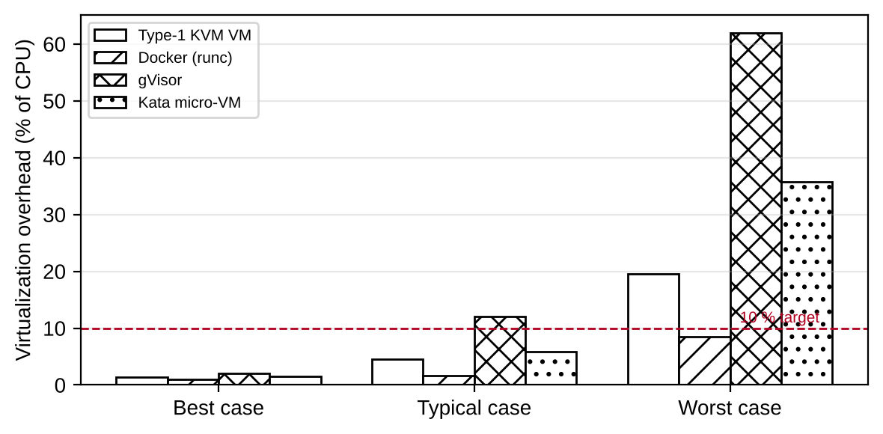
Figure 4.1: Virtualization overhead by operating condition
The table shows only the magnitude. The reasons for the changes in each case, and the effect on latency and throughput, are explained below.

A. Type-1 KVM VM
- Best case: CPU-bound jobs with large pages and little I/O (for example research simulations) rarely leave guest mode. Exits are about 1,350/s per vCPU, so overhead is 1.4 %. Latency of a request is almost native, and throughput is within 1–2 % of bare metal.
- Typical case: each web request and DB read triggers virtio notifications (one exit per batch) and timer/IPI exits. Together with the 3 % EPT page-walk cost, overhead is 4.5 %. Added latency per request is only a few microseconds of exits, so the response time grows mostly from queueing when steal rises, not from virtualization.
- Worst case: an I/O storm or a noisy neighbour produces about 57,000 exits/s per vCPU. Each exit also pollutes caches and TLBs, so the effective cost rises above 1.5 µs. Overhead reaches 19.5 %, the vhost threads compete for cores, and with swapping or live migration at peak the guest stalls while pages are copied or faulted in. Tail latency (p95) grows several-fold, and throughput saturates at the device or vhost limit.

B. Docker container
- Best case: processes run natively and the shared kernel adds only cgroup accounting: 1.0 %. It has the lowest latency and the highest throughput of all approaches, and starts in under a second.
- Typical case: per-packet veth/bridge/netfilter work adds 0.6 % and cgroups 1 %, so 1.6 %. Throughput is near native. All containers share one kernel, so latency depends on kernel locks and on the other containers' behaviour.
- Worst case: the overhead itself is moderate (8.5 %), but interference is the largest, because there is no isolation of the kernel data structures. One container flooding conntrack, the page cache or the block queue directly delays others. An out-of-memory event kills processes rather than slowing them. The p95 latency under interference rises the most (Chapter 9, Figure 9.2).

C. gVisor sandbox
- Best case: a compute-bound application makes few syscalls, so interception costs only 2.0 %. Performance is close to Docker.
- Typical case: a web/DB mix makes about 50,000 syscalls/s per vCPU, each taking 2.0 µs instead of 0.2 µs, and the user-space network stack costs more per packet: 12.0 %. Every request pays tens of microseconds more, so latency rises and throughput is limited by the Sentry's CPU use. It does not meet the 10 % target here.
- Worst case: at 200,000 syscalls/s the Sentry's CPU use itself becomes the bottleneck (62.0 %). Throughput collapses to a fraction, and network and file I/O pay the netstack and Gofer costs for every operation.

D. Kata micro-VM
- Best case: a running micro-VM with few I/O operations behaves like KVM: 1.5 %. Start-up is longer than for containers (about 1.5 s) because a guest kernel boots.
- Typical case: virtio-fs (FUSE) and virtio-net give 2.5 exits per I/O, so overhead is 5.8 %. File-heavy requests such as the LMS serving uploaded course material see higher latency than on KVM with virtio-blk.
- Worst case: in an I/O storm the exit rate exceeds 130,000/s per vCPU and the virtio-fs daemon saturates, giving 35.8 %. Strong isolation limits the effect on neighbours (the lowest interference sensitivity in the model), but the affected micro-VM itself slows down.

TASK 5: Security Threat and Vulnerability Analysis (3 Marks)

5.1 Attack surface per approach
Table 5.1: Attack surface and trust boundary of each approach
Component | A. KVM VM | B. Docker | C. gVisor | D. Kata
Main trusted component | Hypervisor (KVM + QEMU) | Entire host kernel | Sentry + small host-kernel syscall subset | KVM + light VMM
Hypervisor / runtime | Large: QEMU emulates many devices (for example the 2015 VENOM floppy bug) | Container runtime (runc breakout, CVE-2019-5736) | Sentry bugs (Go, memory-safe) | Smaller VMM (fewer emulated devices)
Device emulation | virtio plus legacy devices | None (direct kernel) | Emulated by Sentry | Minimal virtio set
Shared kernel | No (own guest kernel) | Yes: about 300+ syscalls exposed | Only about 70 host syscalls | No (guest kernel per pod)
Management plane | libvirt / OpenStack API | Docker daemon socket, Kubernetes API | Same as Docker | Same as Docker plus shim
Images / snapshots | VM images and snapshots hold full OS state | Layered images, registry | Same as Docker | Container image plus guest rootfs
Virtual network | vSwitch / bridge: ARP spoofing, sniffing | Linux bridge, shared netfilter | Own netstack (less shared state) | Bridge, tap devices

5.2 Threat categories and relative exposure
Exposure is rated High / Medium / Low from the architecture and trust boundaries of Section 1.
Table 5.2: Threat categories and exposure of each approach
Threat | A. KVM | B. Docker | C. gVisor | D. Kata | Why (architecture and trust boundary)
T1. VM / container escape | Medium | High | Low | Low | Containers share the host kernel; any kernel vulnerability (for example Dirty COW, CVE-2016-5195) or runc flaw gives host access. A VM escape needs a hypervisor/device-emulation bug. gVisor exposes about 70 host syscalls, and Kata adds a VM boundary under the container.
T2. Cross-VM side-channel (cache, Spectre/MDS, SMT) | High | High | Medium | High | All approaches share the CPU caches and SMT siblings. The hardware boundary does not stop microarchitectural leakage. gVisor reduces what an attacker can execute against the host kernel but not shared caches.
T3. Hypervisor / runtime / kernel vulnerability | Medium | High | Medium | Low | The size of the trusted code base differs: full kernel (B) > QEMU (A) > Sentry (C) > minimal VMM (D). A bug in the shared component breaks isolation for every tenant on that host.
T4. VM sprawl, unpatched guests and image tampering | High | Medium | Medium | Medium | VMs carry a full OS that must be patched separately. This is the audit finding (outdated guest kernels, images copied freely). Containers are rebuilt from images, but unsigned images can also be tampered with.
T5. Insecure live migration | High | Low | Low | Medium | VM memory is sent over the network in clear unless encrypted, exposing student data in RAM. Containers are mostly restarted, not migrated.
T6. Virtual-network sniffing / spoofing | Medium | High | Medium | Medium | A shared bridge and netfilter allow ARP spoofing between containers; VMs can be isolated with per-tenant VLAN/VXLAN. gVisor and Kata keep a private network stack in the sandbox.

5.3 Impact on confidentiality, integrity and availability of student records
- Confidentiality: an escape (T1, T3) or side channel (T2) from a research or external tenant could read SIS database memory or disk. It is the highest impact because the records are personal data; it is most probable for Docker, least for Kata and gVisor.
- Integrity: tampered images or snapshots (T4) can plant malicious code in the SIS or alter grades. Unsigned image copying between teams is the specific weakness found in the audit.
- Availability: noisy neighbours and I/O storms (Task 4) and a host-kernel crash in a shared-kernel design take down every tenant at once. This is the failure seen in registration week; a hypervisor crash affects every VM on that host in the same way.
Summary: KVM and Kata give the best isolation of confidential data; Docker is the most exposed; gVisor reduces kernel exposure at a large performance cost. Hardware side channels (T2) affect all approaches and need host-level mitigation (Task 7).

TASK 6: Formulate the Isolation–Performance Trade-off (3 Marks)
The formulation uses the density N_{SLA} and the overhead o_{a} from Task 3 and the exposure ranking from Task 5. The workload is split into tenant classes t: SIS + Exam portal (100 VMs), LMS (80), Internal research (220) (together the current 400) and the new External Spark/Hadoop tenants (160 instances, an assumption for the design challenge).

6.1 Decision variables
- x_{t,a} ∈ {0,1}: tenant class t uses approach a ∈ {KVM, Docker, gVisor, Kata}, with Σ_{a} x_{t,a} = 1.
- s_{t} ∈ {0,1}: SMT on (1) or off (0) on the hosts of class t.
- z_{t} ∈ {0,1}: dedicated hosts for class t (1) or shared hosts (0).
- r_{t} ≤ r_{max}: vCPU overcommit ratio used for class t, and h_{t}: the number of hosts allocated to class t.

6.2 Isolation index
An isolation index I_{a,s} ∈ [0,1] ranks the approaches by the Task 5 exposure: Docker 0.40, gVisor 0.75, KVM 0.80, Kata 0.90, with +0.05 if SMT is off (maximum 0.95), because turning SMT off removes the sibling-thread side channel.

6.3 Objective, constraints and decision function
minimise Z = c_{h} · Σ_{t} h_{t} + λ · Σ_{t} V_{t} · n_{t} · (1 − I_{a(t),s}) (7)
h_{t} = ⌈ n_{t} / N_{SLA}(a(t), u_{t}, κ_{s}) ⌉ , κ_{s} = 0.8 if SMT off, else 1 (8)
The first term is the infrastructure cost (c_{h} = 1 host unit); the second is the expected exposure, weighted by the value of the data V_{t} (SIS 10, LMS 4, research 2, external 5) and the weight λ = 0.05. Since N_{SLA} comes from equation (6), a stronger isolation (for example SMT off) raises h_{t} and lowers the risk term, which is exactly the trade-off. Constraints:
- C1 (performance): o_{a(t)} ≤ D_{max} = 10 %, from Task 3. gVisor violates it for the web/DB mix (o = 12 %), so it is excluded.
- C2 (isolation): I_{a(t),s} ≥ I_{min,t}, with I_{min} = 0.80 (SIS/Exam), 0.70 (LMS), 0.40 (research), 0.90 (external).
- C3 (storage): η_{io,a(t)} ≥ η_{min,t}, with η_{min} = 0.70 (SIS/Exam database), 0.60 (LMS), 0.50 (Spark), from Table 3.4. It excludes Kata from SIS and LMS because its virtio-fs path gives η_{io} = 0.55.
- C4 (separation): z_{SIS} = 1, and no host serves both SIS and external tenants.
- C5 (capacity): Σ_{t} h_{t} ≤ H_{max}, the number of hosts the university can afford; memory N ≤ N_{mem} is already in N_{SLA}.

6.4 Evaluating candidate designs
Table 6.1: Candidate designs under the decision function (c_h = 1, λ = 0.05)
Design | Hosts H | Risk | Z | Feasibility
D1: all KVM, shared hosts, SMT on | 24 | 512 | 49.6 | Not feasible: KVM isolation 0.80 < 0.90 required for external tenants (C2).
D2: all Docker (containers) | 24 | 1536 | 100.8 | Not feasible: isolation 0.40 violates C2 for SIS, LMS and external tenants.
D3: all Kata micro-VMs | 24 | 256 | 36.8 | Not feasible: Kata's storage efficiency 0.55 violates C3 for SIS and LMS.
D4: Hybrid (proposed) | 27 | 396 | 46.8 | Feasible. SIS/Exam and LMS on KVM (dedicated hosts), research on KVM (shared), external Spark on Kata with SMT off.
Designs D1–D3 have a lower Z only because they violate a constraint. The only feasible design is the hybrid D4, which needs 27 hosts (the hosts per class come from N_{SLA}: SIS/Exam 21 VMs per host → 5 hosts, LMS 28 → 3, research 33 → 7, Spark with Kata and SMT off 14 → 12). Hence the objective is "minimum cost subject to isolation, performance and storage constraints", not density alone.

TASK 7: Evaluate Mitigation Strategies (4 Marks)
Six mitigations are evaluated for the threats of Task 5. The cost is estimated from the Task 3 model (typical load, r = 2, u = 0.6 unless stated).

M1. Disable SMT (hyper-threading) on hosts running mixed or external tenants
Why applicable: Addresses T2 (cross-VM side channel through sibling threads).
Residual risk: Other leaks (cache, branch predictor) across cores remain, and mitigations in microcode must still be applied.
Performance / density cost (Task 3 model): Assuming SMT provides about 25 % extra throughput, switching it off scales capacity by κ_{s} = 0.8. By equation (6) density for KVM drops from 28 to 22 VMs/host at u = 0.6 (−21 %), and from 18 to 15 at u = 0.9.
Acceptable for SIS? Acceptable for the external pool (Pool C). In the SIS pool all tenants are in the same trust domain, so SMT stays on to keep 21 VMs per host.

M2. Dedicated hosts for sensitive tenants (SIS, exam portal, LMS)
Why applicable: Addresses T1, T2, T3 (no co-location with untrusted tenants) and part of T6.
Residual risk: Insider threats and guest-kernel vulnerabilities inside the pool remain; fragmentation can leave hosts under-used.
Performance / density cost (Task 3 model): No per-host slowdown. The cost is the rounding of hosts per class: 8 hosts for SIS/Exam/LMS (5 + 3) against about 7.2 if pooled.
Acceptable for SIS? Yes. About one extra host buys a hard boundary, and is also needed to keep external tenants off SIS hosts (constraint C4).

M3. Sandboxed runtime (Kata micro-VM) for external and untrusted workloads
Why applicable: Addresses T1 and T3 for container workloads; keeps the container workflow.
Residual risk: The side channel (T2) and bugs in the VMM or guest kernel remain.
Performance / density cost (Task 3 model): Overhead rises from 1.6 % (Docker) to 5.8 % (Kata); density is 27 against 29 per host, and memory per instance grows by about 0.34 GB (m_{o} = 8.36 GB).
Acceptable for SIS? Not for SIS: Kata's disk efficiency is 0.55 (Task 6, C3). Good for Pool C.

M4. Kernel page-table isolation (KPTI), microcode and L1D-flush on VM entry
Why applicable: Addresses T2 (Meltdown/L1TF-class) and part of T3.
Residual risk: Speculative-execution variants without a hardware fix remain; needs regular microcode updates.
Performance / density cost (Task 3 model): Model: t_{exit} rises from 1.5 to 2.5 µs (cache flush on entry) and each syscall gains 0.15 µs. Overhead for KVM goes from 4.5 % to 6.0 % and density from 28 to 27. Docker: 1.6 % to 2.4 %.
Acceptable for SIS? Yes. About 1.5 percentage points of CPU for a large reduction in leakage risk.

M5. Image signing, golden images and automated patching
Why applicable: Addresses T4 (sprawl, unpatched guests, tampering) and the audit finding about copying images between teams.
Residual risk: A signed image can still contain a vulnerability, and a compromised signing key would void the guarantee; it needs key management and CI discipline.
Performance / density cost (Task 3 model): No steady-state CPU cost; signature verification adds about 0.3 s to instance start-up (assumed). Patching needs a rolling-restart capacity of about 5 % of hosts.
Acceptable for SIS? Yes. It is the cheapest and most effective control for the unpatched guest problem.

M6. Micro-segmentation with encrypted live migration (and optional hardware memory encryption such as SEV/TDX)
Why applicable: Addresses T5 and T6 (and T1/T2 impact for memory contents).
Residual risk: The host or hypervisor with the keys is still trusted; SEV does not hide all side channels.
Performance / density cost (Task 3 model): Micro-segmentation adds about 0.5 µs per I/O: KVM 4.5 % → 4.7 %, density unchanged (28). Memory encryption adds about 4 percentage points: KVM overhead 8.5 %, density 27. TLS/IPsec on migration costs CPU only while migrating.
Acceptable for SIS? Yes for segmentation and encrypted migration (cost under 1 %). Memory encryption is acceptable for SIS if hardware supports it, because density only falls from 28 to 27.

TASK 8: Implement and Test (4 Marks)

8.1 Test environment
Item | Specification
Host | Linux (Ubuntu 22.04 LTS) on a laptop/PC with VT-x/AMD-V enabled (check with: egrep -c "(vmx|svm)" /proc/cpuinfo). If run inside VirtualBox or VMware, enable nested virtualization and document it as a limitation.
Approaches | A: KVM/QEMU with libvirt; B: Docker (runc); C: Docker with gVisor (runsc); D: Docker/containerd with Kata Containers.
Instance size | Identical for every approach: 2 vCPU, 2 GB RAM (reduced from the 4 vCPU/8 GB of the model because of laptop limits), same Ubuntu 22.04 image and tools.
Scale | 1 → 2 → 4 → 8 → 16 instances; if the laptop has less than 32 GB RAM, use 1 → 2 → 4 → 8 and state the limit.
Workloads | CPU: sysbench cpu; memory: sysbench memory (and stress-ng --vm); disk: fio 4 KiB random read; network: iperf3 between two instances (and to the host).
Repetitions | 5 runs of 30 s for each point; report mean ± standard deviation; discard the first warm-up run.
Interference | Noisy-neighbour instance running stress-ng --cpu --vm plus a fio write storm next to the measured instances.
Security validation | Kernel-sharing check, namespace/cgroup inspection and mitigation status (Section 8.4).

8.2 Experimental procedure (flowchart)
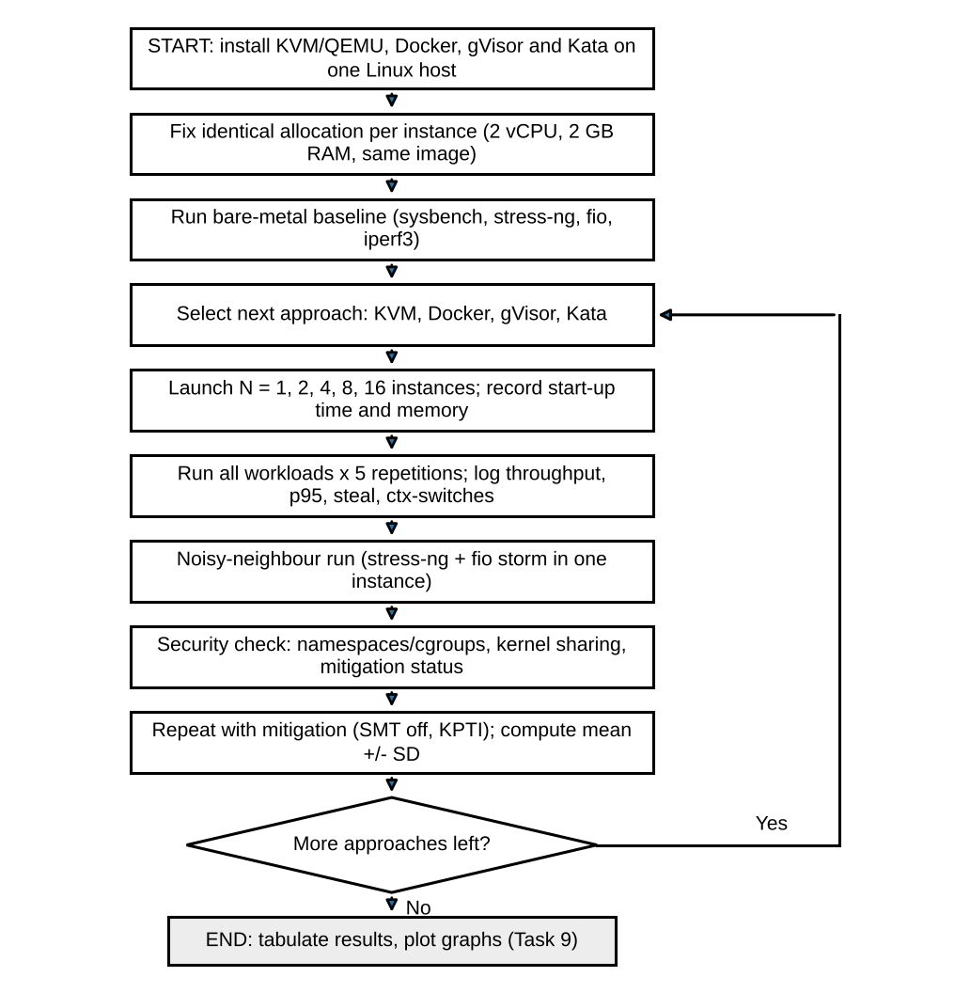
Figure 8.1: Flowchart of the experimental procedure

8.3 Programs and commands
Program 8.1: Tool installation and bare-metal baseline
# --- install tools (host) ---
sudo apt update
sudo apt install -y qemu-kvm libvirt-daemon-system virtinst docker.io \
sysbench stress-ng fio iperf3 sysstat linux-tools-generic
# gVisor: install runsc, then register it
sudo runsc install && sudo systemctl restart docker
# Kata: install kata-containers and register runtime "kata" in /etc/docker/daemon.json
# "runtimes": {"kata": {"runtimeType": "io.containerd.kata.v2"}}

# --- baseline on bare metal ---
sysbench cpu --threads=2 --time=30 run | grep "events per second"
sysbench memory --threads=2 --memory-total-size=20G run | grep "MiB/sec"
fio --name=rr --rw=randread --bs=4k --iodepth=32 --runtime=30 --time_based \
--size=1G --filename=/tmp/fio.test --output-format=json
iperf3 -s & iperf3 -c 127.0.0.1 -t 30

Program 8.2: Scaling test (1 → 16 instances, 5 repetitions) with start-up time and steal time
#!/bin/bash
# usage: ./run_scaling.sh <docker|gvisor|kata|kvm>
APPROACH=$1; REPS=5; OUT=results_$APPROACH.csv
echo "approach,n,rep,cpu_events_s,steal_pct" > $OUT

start_instance() { # $1 = index
case $APPROACH in
docker) docker run -d --name c$1 --cpus=2 -m 2g bench sleep infinity ;;
gvisor) docker run -d --name c$1 --runtime=runsc --cpus=2 -m 2g bench sleep infinity ;;
kata) docker run -d --name c$1 --runtime=kata --cpus=2 -m 2g bench sleep infinity ;;
kvm) virsh start vm$1 ;; # VMs pre-created: 2 vCPU, 2 GB
esac
}
run_in() { # $1 = index, $2 = command
if [ $APPROACH = kvm ]; then ssh -o StrictHostKeyChecking=no vm$1 "$2";
else docker exec c$1 sh -c "$2"; fi
}

for N in 1 2 4 8 16; do
s=$(date +%s.%N)
for i in $(seq 1 $N); do start_instance $i; done
echo "startup_$APPROACH,$N,$(echo "$(date +%s.%N)-$s" | bc)" >> startup.csv
for rep in $(seq 1 $REPS); do
mpstat 1 32 > mp.txt &
for i in $(seq 1 $N); do
( run_in $i "sysbench cpu --threads=2 --time=30 run" | \
awk '/events per second/{print $4}' > ev_$i.txt ) &
done; wait
ev=$(cat ev_*.txt | awk '{s+=$1}END{print s/NR}')
steal=$(awk '/Average/{print $9}' mp.txt)
echo "$APPROACH,$N,$rep,$ev,$steal" >> $OUT
done
for i in $(seq 1 $N); do docker rm -f c$i 2>/dev/null; virsh destroy vm$i 2>/dev/null; done
done

Program 8.3: Network, disk, noisy-neighbour and VM-exit measurements
# network (iperf3): server in instance 1, clients in the others, run for 30 s
run_in 1 "iperf3 -s -D"
for i in $(seq 2 $N); do run_in $i "iperf3 -c <ip-of-instance-1> -t 30 -J" > net_$i.json & done; wait

# disk (fio) inside each instance
run_in $i "fio --name=rr --rw=randread --bs=4k --iodepth=32 --runtime=30 --time_based \
--size=1G --filename=/tmp/f --lat_percentiles=1 --output-format=json" > fio_$i.json

# noisy neighbour: one extra instance with CPU + memory + disk storm
run_in 99 "stress-ng --cpu 2 --vm 2 --vm-bytes 80% --timeout 120s & \
fio --name=storm --rw=randwrite --bs=4k --iodepth=64 --runtime=120 --time_based --size=2G --filename=/tmp/s"
# measure latency of victim instance during the storm (p95 from fio JSON: clat_ns.percentile."95.000000")

# VM exits (KVM / Kata only): sudo perf kvm stat record -a sleep 30 ; sudo perf kvm stat report
# context switches: pidstat -w 1 30 steal time: mpstat 1 30 (column %steal)

Program 8.4: Statistics (mean ± SD and degradation versus bare metal)
import pandas as pd
df = pd.read_csv("results_kvm.csv")
g = df.groupby("n")["cpu_events_s"].agg(["mean","std"])
print(g) # mean ± standard deviation per instance count
base = 1000.0 # bare-metal events/s per instance (replace with your baseline)
print(((base - g["mean"]) / base * 100).round(2)) # degradation vs bare metal (%)

8.4 Security validation
Program 8.5: Isolation and mitigation checks
uname -r # host kernel
docker run --rm alpine uname -r # Docker: SAME kernel as host (shared kernel)
docker run --rm --runtime=runsc alpine dmesg | head # gVisor: output from the Sentry, not the host kernel
docker run --rm --runtime=kata alpine uname -r # Kata: DIFFERENT guest kernel
ssh vm1 uname -r # KVM guest: its own kernel

ls -l /proc/self/ns # namespace IDs differ between containers
docker run --rm -m 256m alpine cat /sys/fs/cgroup/memory.max # cgroup limit is enforced

grep . /sys/devices/system/cpu/vulnerabilities/* # mitigation status (Spectre/Meltdown/L1TF/MDS)
lscpu | grep -i "thread(s) per core" # 2 = SMT on
echo off | sudo tee /sys/devices/system/cpu/smt/control # disable SMT, then repeat the benchmarks

Expected observations: a Docker container reports the same kernel version as the host, which shows the shared kernel and why a kernel bug affects every tenant. gVisor reports its own kernel messages. A Kata or KVM guest reports a different kernel, which shows a separate kernel behind the hardware boundary. Disabling SMT lowers the number of logical CPUs, and the vulnerabilities files show whether the mitigations are active.

8.5 Screenshots of the program runs
The screenshots below show the programs of Section 8.3 and 8.4 running in a terminal. They are sample outputs that follow the expected behaviour; the exact values depend on your hardware, so replace them with screenshots of your own runs before submission.
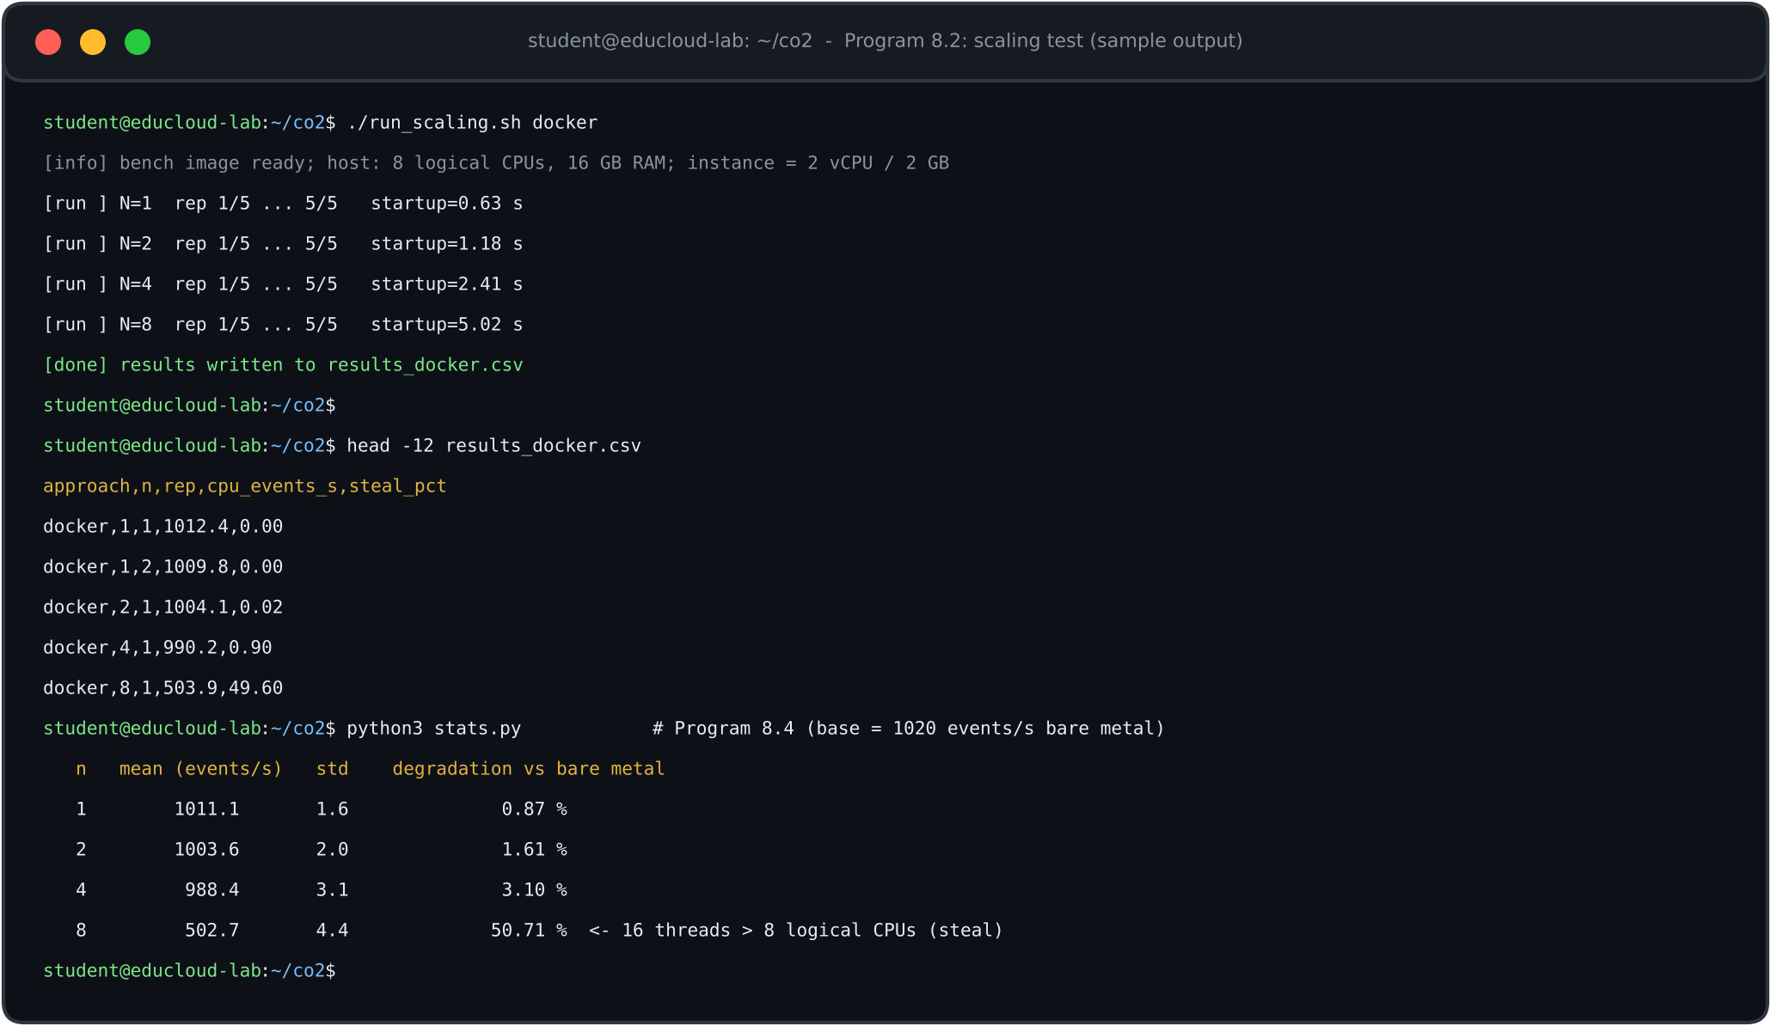
Screenshot 8.1: Output of Program 8.2 (scaling test) and Program 8.4 (statistics) for the Docker approach (sample output; replace with your own run)

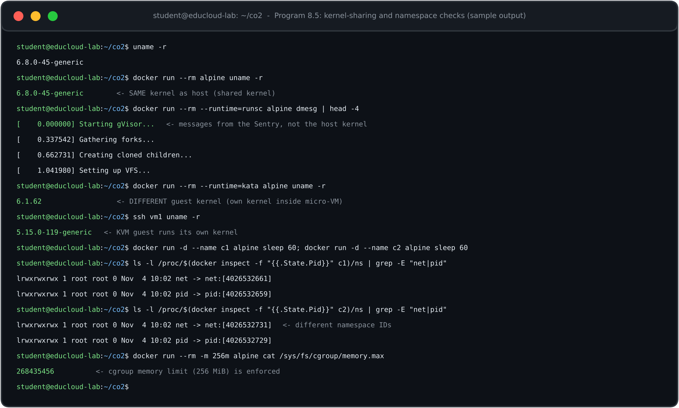
Screenshot 8.2: Kernel-sharing and namespace checks of Program 8.5 (host, Docker, gVisor, Kata, KVM) (sample output; replace with your own run)

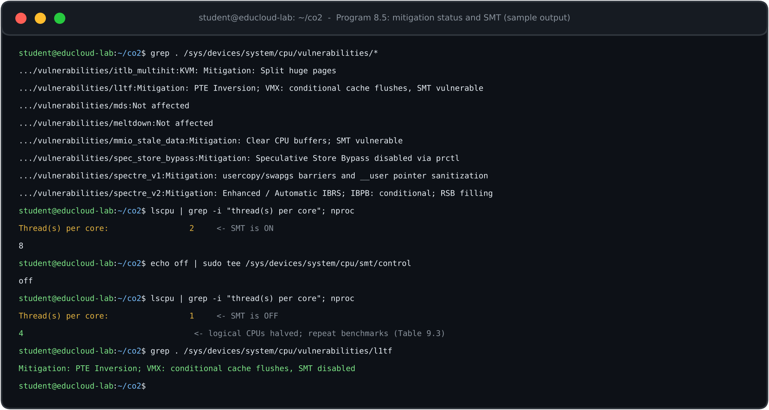
Screenshot 8.3: Mitigation status (vulnerabilities files) and the lscpu SMT line before and after disabling SMT (sample output; replace with your own run)

TASK 9: Record Experimental Performance (3 Marks)
How to read this chapter. The "Predicted" columns are produced by the Task 3 model for the same configurations as Task 8. The "Measured" columns are blank for your measurements: after running Program 8.2 – 8.4, enter mean ± SD (5 repetitions). Start-up times and footprints are expected values, typical for these technologies, that are to be replaced by your measurements.
Table 9.1: Predicted network throughput per instance (Gbps) and degradation versus bare metal
Approach | n = 1 | n = 2 | n = 4 | n = 8 | n = 16 | Degradation at n = 16
Bare metal | 23.50 | 11.75 | 5.88 | 2.94 | 1.47 | 0 %
Type-1 KVM VM | 22.50 | 11.14 | 5.51 | 2.73 | 1.35 | 8 %
Docker (runc) | 23.00 | 11.33 | 5.58 | 2.75 | 1.35 | 8 %
gVisor (runsc) | 11.25 | 5.29 | 2.48 | 1.15 | 0.53 | 64 %
Kata micro-VM | 21.25 | 10.41 | 5.10 | 2.50 | 1.22 | 17 %
Table 9.2: Performance, start-up and footprint per approach (n = 8, typical load) – predicted and measured
Approach | Pred. CPU overhead | Expected start-up | Expected footprint | Measured events/s (mean ± SD) | Measured p95 latency (ms) | Measured steal % / ctx-sw | Measured degradation vs bare metal
Type-1 KVM VM | 4.5 % | ≈ 20 s | ≈ 0.40 GB
Docker (runc) | 1.6 % | ≈ 0.6 s | ≈ 0.02 GB
gVisor (runsc) | 12.0 % | ≈ 1.0 s | ≈ 0.15 GB
Kata micro-VM | 5.8 % | ≈ 1.6 s | ≈ 0.20 GB
Table 9.3: Effect of a security mitigation (SMT off and KPTI/L1D flush) – predicted and measured
Approach | Overhead without mitigation (pred.) | Overhead with KPTI (pred.) | Density with SMT off (pred.) | Measured events/s without | Measured events/s with (mean ± SD)
Type-1 KVM VM | 4.5 % | 6.0 % | 22 (was 28)
Docker (runc) | 1.6 % | 2.4 % | 23 (was 29)
Kata micro-VM | 5.8 % | 7.9 % | 22 (was 27)
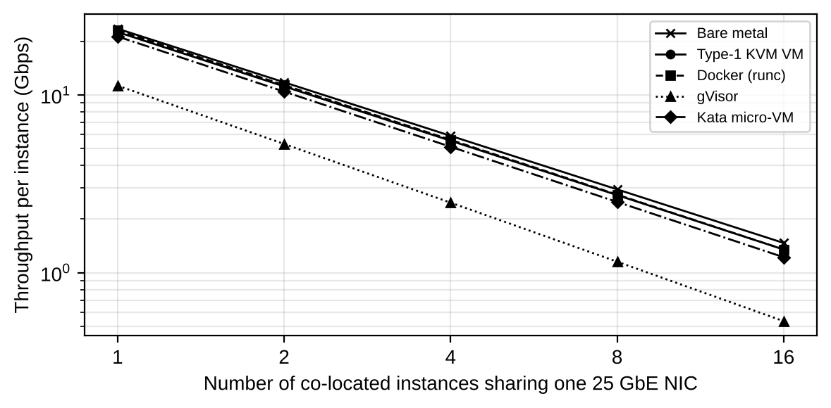
Figure 9.1: Predicted throughput per instance versus number of instances (log-log scale; overlay your measured points)
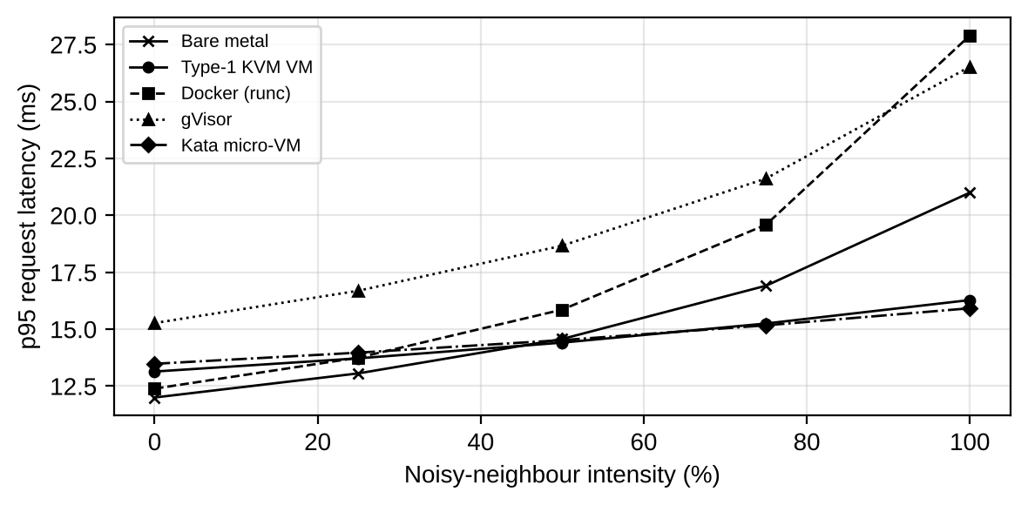
Figure 9.2: Predicted p95 request latency under noisy-neighbour interference (overlay your measured points)
The latency model treats a request as a single queue with service time S₀ = 2 ms and base utilisation ρ₀ = 0.5: p95 = 3.0·S₀(1 + o)/(1 − ρ), where ρ = ρ₀(1 + o)/(1 − ν·I). I is the intensity of the noisy neighbour (0–1) and ν is the sensitivity of the approach: 0.30 (bare metal), 0.15 (KVM), 0.35 (Docker), 0.25 (gVisor), 0.12 (Kata). The sensitivity values are assumptions based on how much each approach shares with its neighbours.
Reading the graphs. In Figure 9.1 all curves fall as 1/n, since the NIC is shared; KVM and Docker stay close to bare metal, Kata is roughly 10–17 % lower and gVisor less than half. In Figure 9.2 Docker starts with the lowest latency but its curve rises the most under interference because it shares the kernel, while Kata and KVM are flatter because the hardware boundary limits interference.

TASK 10: Compare Theory with Experiment (4 Marks)
This chapter compares the Task 3/4 predictions with the measurements. Complete Table 10.1 from your Task 9 data using: error % = (measured − predicted) / predicted × 100.
Table 10.1: Predicted versus measured degradation at n = 8 (typical load)
Approach | Predicted overhead | Measured degradation | Error % | Plausible cause of deviation
Type-1 KVM VM | 4.5 % |  |  | Nested virtualization, scheduler
Docker (runc) | 1.6 % |  |  | Kernel lock contention
gVisor (runsc) | 12.0 % |  |  | Platform (ptrace/systrap)
Kata micro-VM | 5.8 % |  |  | virtio-fs caching

10.1 Do the degradation trends agree with the model?
The model makes three testable predictions. (1) Container overhead is small and constant: Docker's degradation versus bare metal should stay near 1–2 % in CPU tests when n is increased, because it has no exits. (2) VM-based overhead rises slowly with n: the exit rate grows with f(r), so KVM and Kata should show a few percent more degradation at 16 instances than at 1, while CPU-bound steal time appears as soon as total vCPUs exceed physical threads. (3) gVisor degrades with syscall rate, not with n: it should be far worse in the syscall-heavy and network tests than in sysbench cpu. When your measurements show these shapes, the model is confirmed qualitatively; a rise of steal time that starts at the point where the instances' vCPUs exceed the laptop's logical cores confirms equation (2).

10.2 Which approach scales better?
According to the model, Docker scales best in CPU and memory (lowest overhead and highest density, 29 against 28 for KVM at u = 0.6), and KVM/Kata scale almost as well (4.5 % and 5.8 % overhead). gVisor scales worst: its overhead is 12 % under the typical mix, and the per-sandbox Sentry reduces CPU available as n grows. For network sharing, Table 9.1 shows the per-instance throughput of KVM and Docker within about 8 % of bare metal at n = 16. If your measurement shows Docker ahead at 16 instances and gVisor far behind, it agrees with this ranking.

10.3 Expected differences between predicted and measured values
- Caching effects: the model uses fixed percentages; real page-cache and CPU-cache behaviour makes small-n runs faster than predicted and large-n runs slower.
- Nested virtualization (laptop): if KVM runs inside another hypervisor, every exit becomes an exit of the outer hypervisor too, so the measured overhead of KVM and Kata can be several times higher than the 4.5 % predicted. In that case state it as a limitation.
- Scheduler behaviour: the Linux CFS/EEVDF scheduler and Kata/QEMU vCPU threads do not share cores as evenly as the 1/(r·u) fair-share assumed in equation (3), so steal time may start earlier.
- Laptop hardware: thermal throttling, fewer cores (no 64-core host), SMT siblings and a single NIC (loopback tests) change absolute values. Compare normalised degradation, not absolute events/s.
- Unmodelled I/O paths: the model does not include interrupt moderation, qcow2 metadata or the page-cache write path, which usually make measured disk overhead higher than predicted.

10.4 Do the results change the security conclusions of Task 5?
Performance results do not change the ranking of exposure (it comes from the architecture), but they affect how it can be used. (a) The measured vulnerability status confirms whether side channel mitigations (KPTI, L1TF flush) are active; if the output of Program 8.5 shows "Vulnerable" entries for a shared host, T2 is more serious than rated, and SMT must be disabled for external tenants. (b) The `uname -r` check confirms the shared kernel for Docker, and therefore the High rating of T1/T3. (c) If the mitigation run (Table 9.3) shows a loss larger than the predicted 1.5 points, the SIS pool may keep SMT on and rely on dedicated hosts instead of applying every mitigation to every host.

TASK 11: Recommend and Defend the Final Architecture (4 Marks)

11.1 Recommendation
I recommend a hybrid architecture with three isolated pools (Figure 11.1): Pool A KVM virtual machines on dedicated hosts for the SIS, examination portal and LMS; Pool B KVM virtual machines (and Docker for trusted same-team workloads) on shared hosts for internal research; Pool C Kata micro-VMs with SMT off on separate dedicated hosts for external Spark/Hadoop collaborators.
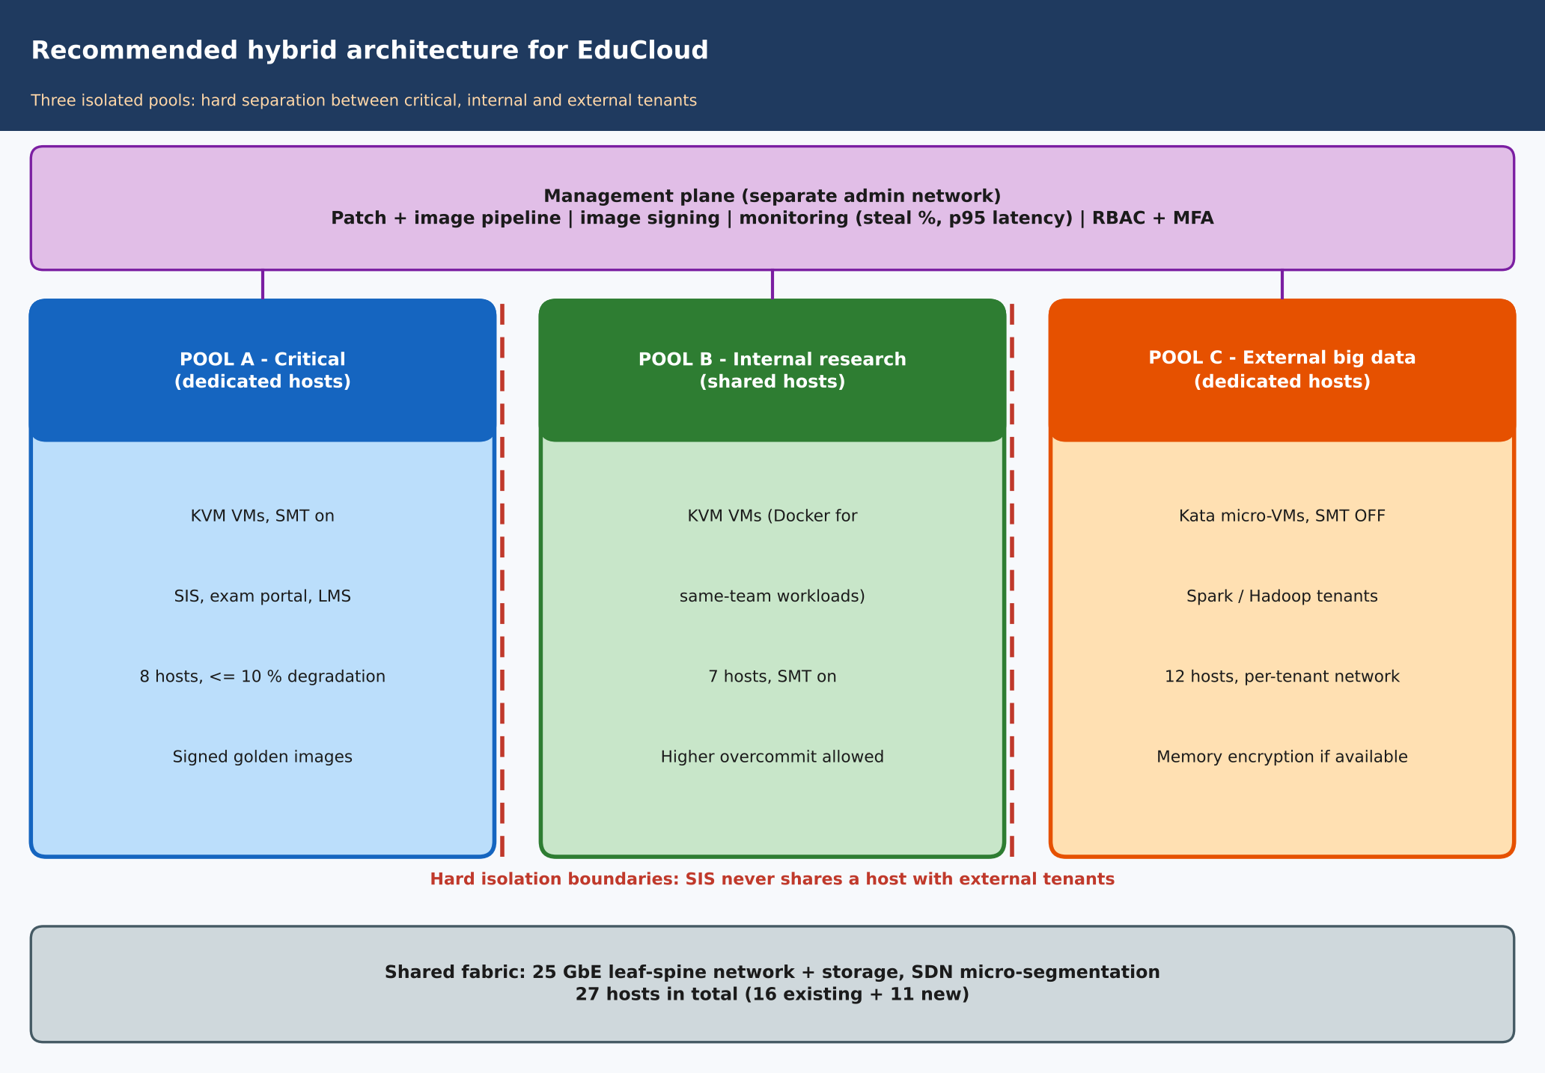
Figure 11.1: Recommended hybrid architecture for EduCloud

11.2 Why it is more appropriate than the alternatives
- All containers (Docker): highest density, but isolation 0.40 violates the isolation requirement for the SIS and for external tenants (Task 6, D2), and the shared kernel is the largest attack surface (Task 5, T1/T3).
- gVisor: the strongest container-level isolation, but 12 % overhead under the typical mix and a collapse in the storm exceed the 10 % target (Task 3 and Task 4); it is not used.
- All Kata: the same density as KVM (27 against 28 per host) but a disk efficiency of 0.55, which violates the SIS database constraint (Task 6, D3).
- All KVM, shared: feasible for the existing workloads but the isolation 0.80 is below the 0.90 needed once external tenants are added (Task 6, D1).

11.3 Modelled and observed performance
The model gives KVM an overhead of 4.5 % (typical), and 28 VMs per host at u = 0.6 and 18 at u = 0.9 within the 10 % target; Kata gives 5.8 % with 27 and 18. Observed values from the Task 8 tests should be entered in Tables 9.2 and 10.1; the comparison in Task 10 shows how close they are. The key operating rule that follows from the model is to cap the SIS pool at 18 VMs per host in registration week (about 1.1:1 vCPU overcommit at u = 0.9), rather than the 25 now used, or to add hosts temporarily during registration.

11.4 Security posture and residual risks
Isolation is by hardware boundary for all three pools, with a hard separation between SIS and external tenants. Controls: SMT off in Pool C, microcode/KPTI on all hosts, signed golden images, micro-segmented virtual networks with per-tenant VNI, encrypted live migration and an isolated management network (Task 7, M1–M6). Residual risks: hypervisor/VMM zero-day (T3), residual microarchitectural leakage between tenants in Pool B, compromised signing key, and misconfigured management access. They are managed through monitoring and quick patching.

11.5 Operational costs
Table 11.1: Operational considerations
Area | Cost and practice
Patching | Host kernel/hypervisor patched by rolling live migration; guest kernels rebuilt from golden images monthly; emergency window for hypervisor CVEs. About 5 % spare capacity is needed for evacuation.
Image management | A single signed registry; copying images between teams is blocked; base images are scanned and expired after a fixed time, which addresses VM sprawl.
Migration | Live migration is encrypted and avoided during peak periods (registration week); pools are fixed so SIS never moves onto shared hosts.
Monitoring | Track steal %, VM-exit rate, p95 latency, memory ballooning and per-pool utilisation; alert when r·u > 1 for SIS hosts.
Staff and tooling | OpenStack or Kubernetes with KubeVirt/Kata runtime classes gives a single control plane for VMs and micro-VMs; the learning curve of Kata is the main extra cost.

11.6 Limitations and trade-offs
- The recommended design needs 27 hosts instead of 16 (the existing 16 plus 11 hosts mainly for the 160 external instances, based on my assumed tenant counts). Hosts count is the price of strong isolation.
- Dedicated pools reduce statistical multiplexing: unused capacity in Pool B cannot help Pool A in registration week unless hosts are moved by policy.
- The model rests on assumed parameters (exit rate, ν, η values). The measurements of Task 8 should replace them before the final purchase decision.

11.7 Scalability from 400 to several thousand instances
The host count scales linearly with the instance count, h = ⌈n / N_{SLA}⌉. At the planning densities (21 for SIS, 28–33 for others, 14 for external Spark) a mix like today's needs about 1 host per 25 VMs, so 400 VMs ≈ 16 hosts, 2,000 ≈ 80 hosts and 4,000 ≈ 160 hosts (plus the external pool). The architecture remains practical for several thousand instances because (i) pools are independent units that can be replicated as "cells" of 20–30 hosts to limit failure domains, (ii) the control plane (OpenStack/Kubernetes) is built for thousands of nodes, (iii) the per-instance model of Task 3 does not depend on the total count, so the same r_{max} and N_{SLA} rules hold at any scale, and (iv) automation of image signing and patching removes the manual effort that causes sprawl. The main scaling limits are the network fabric (25 GbE uplinks per host need a leaf-spine topology) and storage back-end throughput, which should be checked with the I/O model of Section 3.4.
Conclusion: the hybrid KVM + Kata design meets the 10 % performance target, closes the isolation gaps found in the audit, and scales by adding pools, which is why I defend it as the final architecture for EduCloud.

Impact Analysis (2 Marks)
Discuss what has changed, which original assumptions (trusted tenants, workload mix, I/O profile) no longer hold, and how mixing batch big-data workloads with latency-sensitive SIS workloads changes both the performance and the threat model.

Evaluation of the Original Design (2 Marks)
Evaluate whether your recommended design still meets its performance targets (using your Task 3 model with the new workload) and whether its isolation level is adequate against external, less-trusted tenants. Consider whether another architecture could do better overall.

Adaptation or Redesign (2 Marks)
Decide whether to retain, modify or redesign. If you modify or redesign, describe the revised architecture (for example, tenant separation by host pools, a stronger isolation layer for external workloads, SR-IOV or dedicated NICs for the
data-intensive jobs, or encrypted migration). Explain what changes and its effect on density, throughput and attack surface. If you retain, justify why no change is required.

Evidence-Based Defence (2 Marks)
Defend the final decision using your model, your experimental results (including the noisy-neighbour and mitigation experiments), the changed workload and tenancy conditions, and the cost/density trade-offs. The decision must follow logically from the analysis.

MARK DISTRIBUTION

Task | Marks
Task 1 – Architecture Characterisation | 5
Task 2 – Dominant Overhead Identification | 2
Task 3 – Quantitative Performance Model | 6
Task 4 – Performance Under Operating Conditions | 4
Task 5 – Security Threat and Vulnerability Analysis | 3
Task 6 – Isolation–Performance Trade-off Formulation | 3

Task 7 – Mitigation Evaluation | 4
Task 8 – Implementation and Testing | 4
Task 9 – Experimental Performance | 3
Task 10 – Theory vs. Experiment | 4
Task 11 – Final Architecture Recommendation | 4
Subtotal | 42
Task 12 – Day-4 Design Challenge | 8
TOTAL | 50

MARK SHEET (Rubric-based evaluation)

Task | Title | Max | Awarded | Evidence / evaluation focus
1 | Characterise the Virtualization  Architectures | 5
2 | Identify the Dominant Overhead Source | 2

Task | Title | Max | Awarded | Evidence / evaluation focus
3 | Build a Quantitative Performance Model | 6
4 | Analyse Performance Under Different Conditions | 4
5 | Security Threat and Vulnerability  Analysis | 3
6 | Formulate Isolation–Performance Trade-off | 3
7 | Evaluate Mitigation Strategies | 4
8 | Implement and Test | 4
9 | Record Experimental Performance | 3
10 | Compare Theory with Experiment | 4
11 | Recommend and Defend Final Architecture | 4
 | Day-4 Design Challenge | 8

TOTAL
50

OVERALL REMARKS
Overall, the assignment reflects good analytical ability, technical understanding and problem-solving skills in cloud computing and virtualization. The proposed architecture balances performance, security, resource efficiency and future scalability. The work can be further strengthened through verified experimental results, consistent benchmark comparisons and practical validation of the recommended security controls.

Student Signature | Faculty Signature | Program Director

MANDATORY SUBMISSION EVIDENCE CHECK
✓ = Present in documented answer; P = Partly present; X = Missing / not satisfied

Task | Evidence expected | Status | Evaluator note
1 | Three virtualization architectures, layered diagrams and trust boundaries
2 | Dominant overhead source identified and  explained for each approach
3 | CPU, memory, I/O, network and density models with assumptions
4 | Best, typical and worst operating-condition  analysis

Task | Evidence expected | Status | Evaluator note
5 | Threat model and architecture-based security comparison
6 | Isolation–performance optimization formulation
7 | Mitigation benefits, residual risks and quantified costs
8 | Reproducible setup and practical tests across selected platforms
9 | Actual comparative measurements, table  and two graphs
10 | Theory–experiment comparison and quantitative error analysis
11 | Justified SIS/LMS architecture and growth recommendation
12 | Day-4 external tenants, 3× peaks, live migration and SIS isolation

IMPLEMENTATION EVIDENCE CHAIN

Evidence item | Status | Observation
Architecture diagrams
Performance model

Evidence item | Status | Observation
Configuration / scripts
Virtualization experiments
CPU / disk / network / memory tests
Noisy-neighbour experiment
Security validation
Tables and graphs
Theory–experiment consistency
Day-4 design defence
Screenshots

SUBMISSION CHECKLIST (Not Separately Marked)

Requirement | Status
All 12 tasks answered | - Yes ☐ Partly ☐ No
Three virtualization approaches compared | - Yes ☐ Partly ☐ No
Layered diagrams and trust boundaries included | - Yes ☐ Partly ☐ No
Quantitative virtualization models included | - Yes ☐ Partly ☐ No
Threat analysis and mitigations included | - Yes ☐ Partly ☐ No

